SQL Assignment 10
Joining a table with itself .
1)

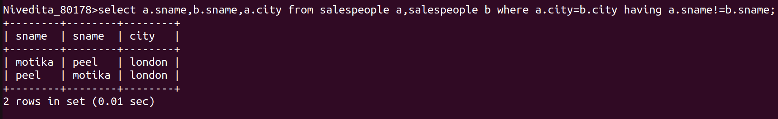
2)

