SQL Assignment 15

Using subqueries with DML Commands.
1)
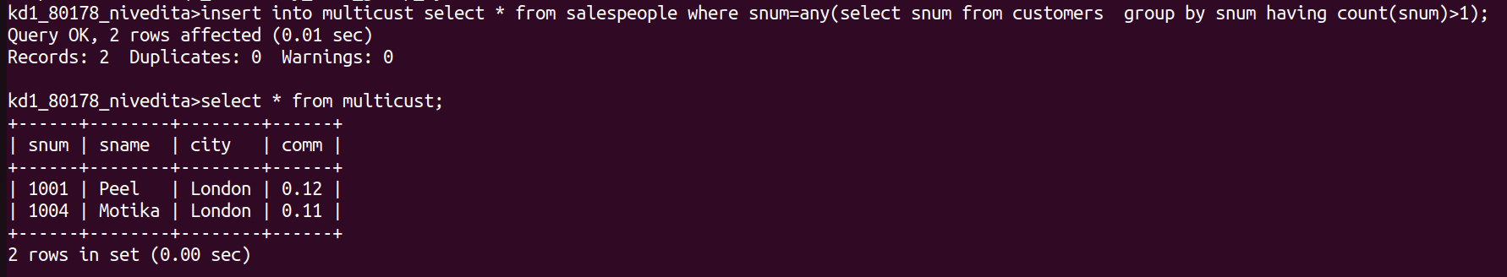
2)

3)
