SQL Assignment 01
Creating sample tables and inserting values.
Create the following tables with the given structures and insert sample data as specified:

A)Salespeople:
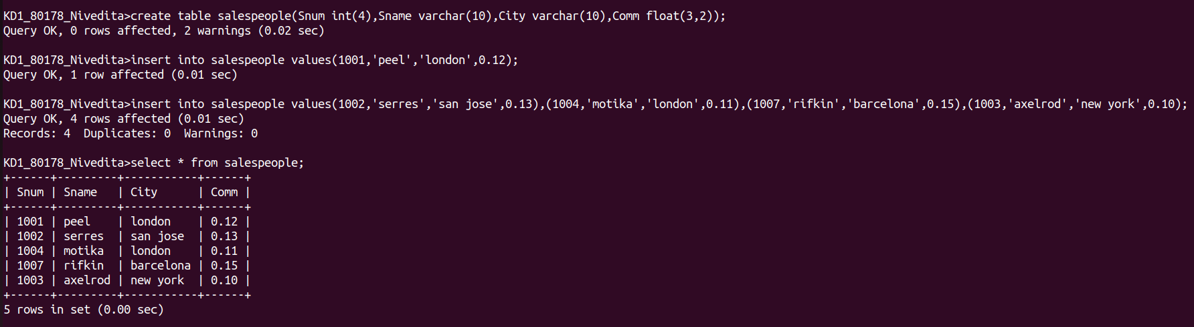
B)Customers:
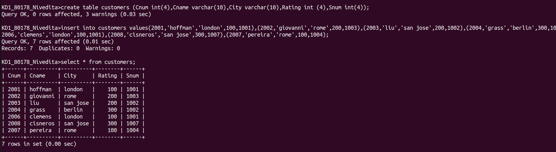

C)Orders:
