SQL Assignment 9
Querying Multiple tables at once .
1)
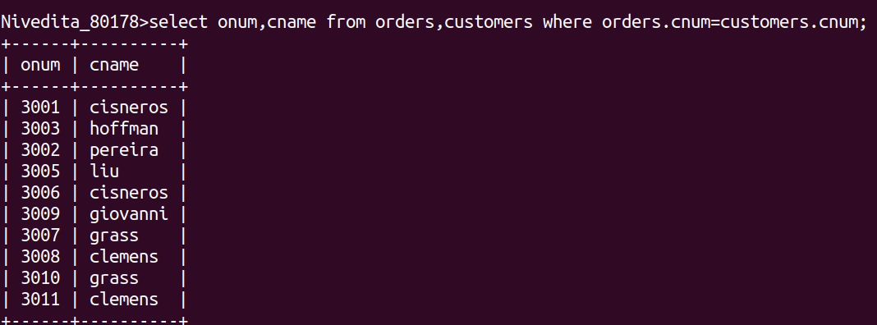
2)

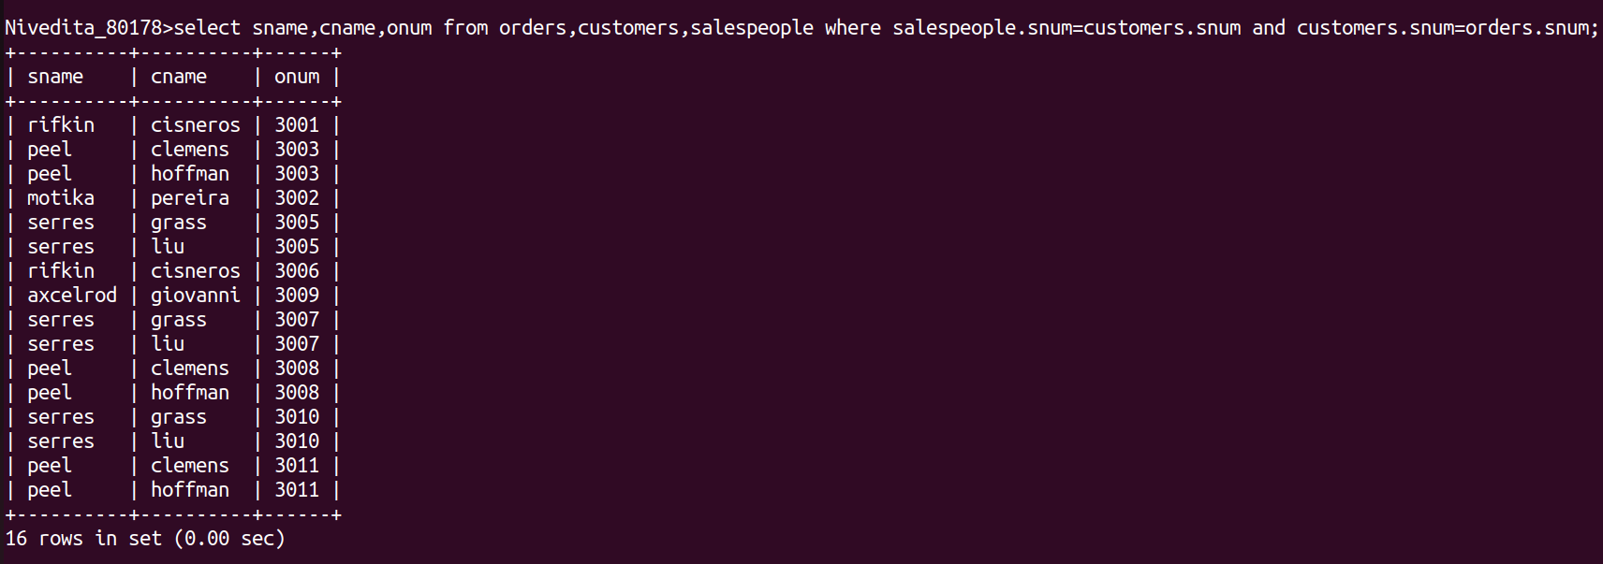

3)

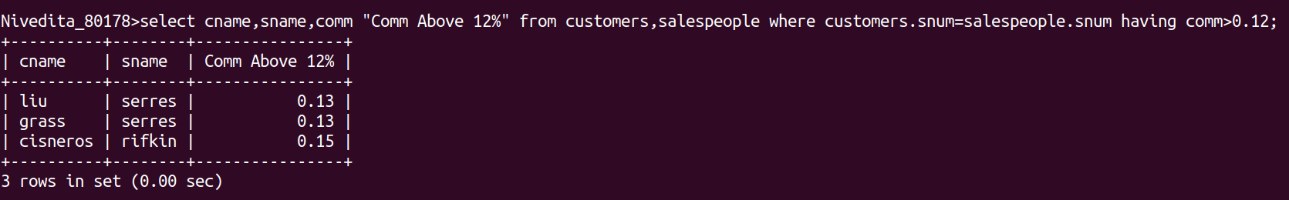

4)

