SQL Assignment 6
Using special Operators in conditions.
1)Write queries that would produce all orders taken on october 3rd or 4th , 1990.

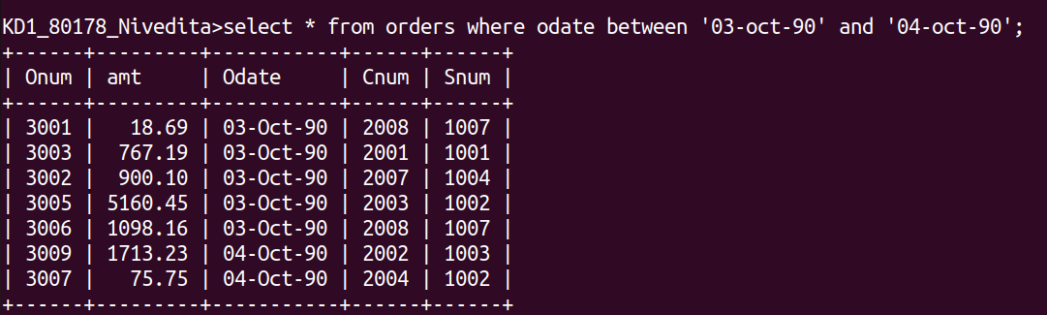
2)Write a query that selects all of the customers serviced by peel or motika.

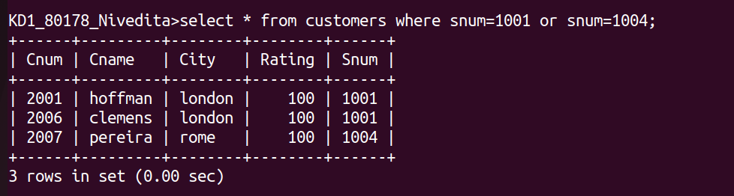

3)Write a query that will produce all the customers whose begin with a letter from ‘a’ to ‘g’.

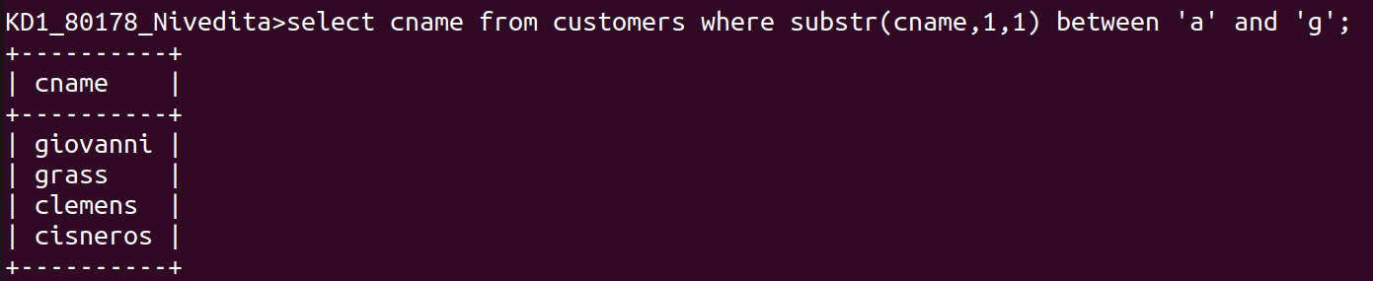
4)Write a query that will produce all the customers whose begin with a letter from ‘c’ .

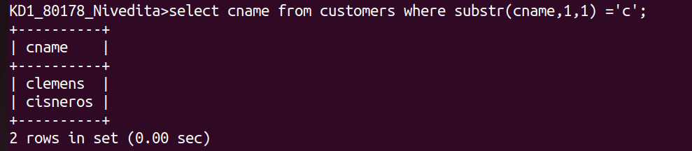
5)Write a query that selects all orders except those with zeros or non null in amt field.
