Assignment-4
Retrieving Information from Tables

1.select Onum,Amt,Odate from ORDERS;
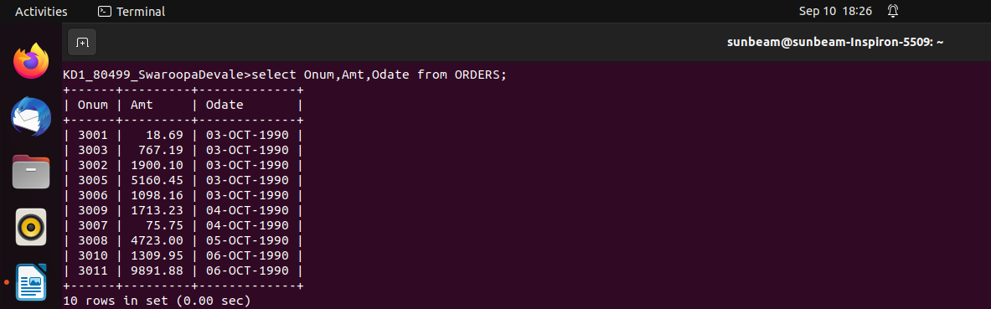

2.select * from CUSTOMERS where CNUM=1001;
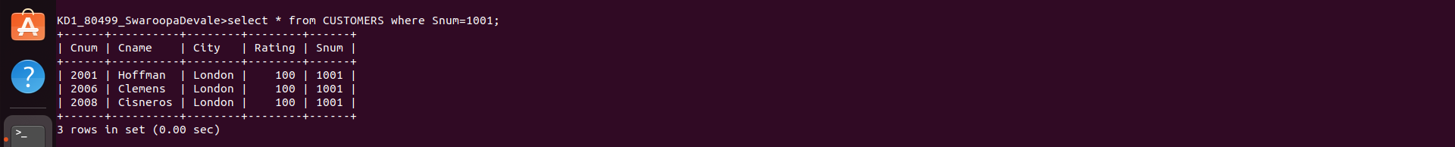

3.select city,sname,snum,comm from SALESPEOPLE;
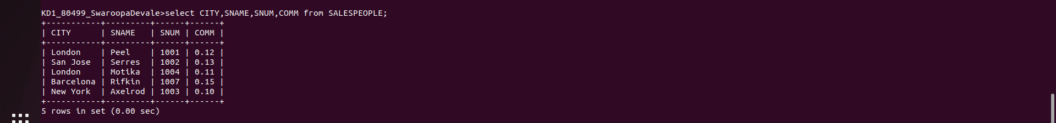

4.select RATING,SNAME from CUSTOMERS where CITY=’San Jose’;

