Assignment-15

1.
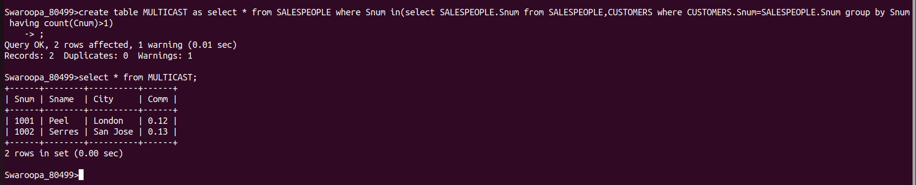
2.
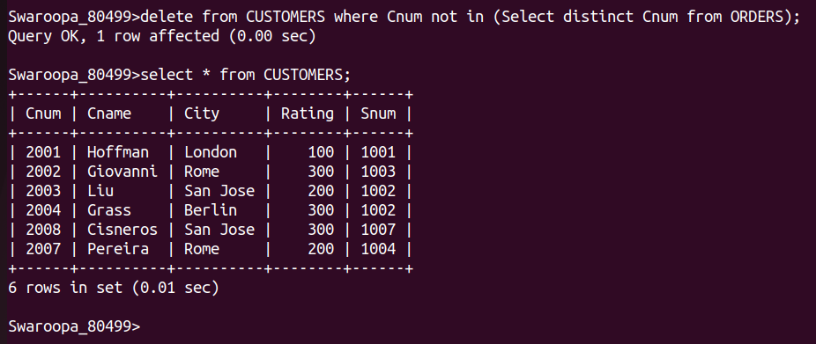

3.

