Assignment-7

Summarizing data with aggregate functions

1.
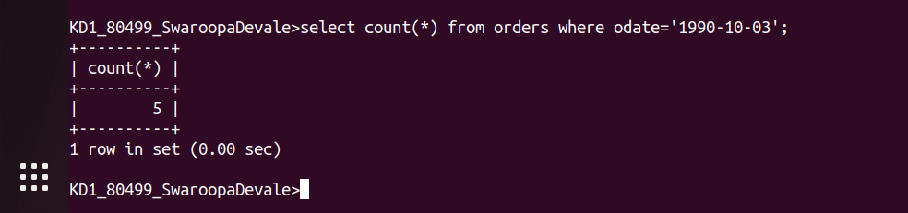

2.
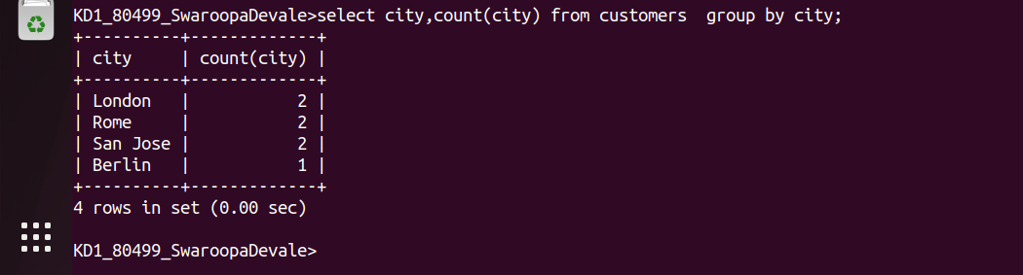

3.
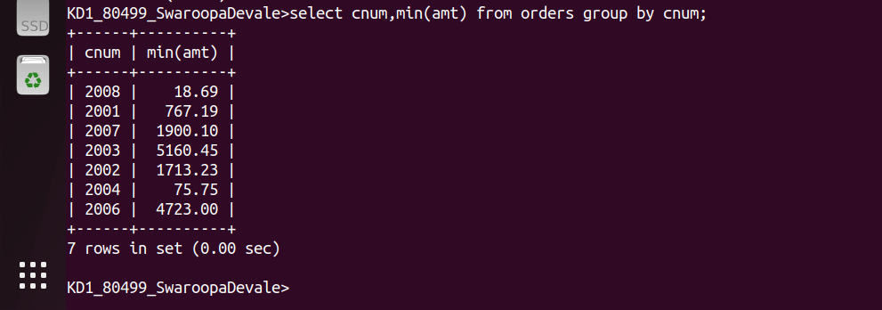

4.

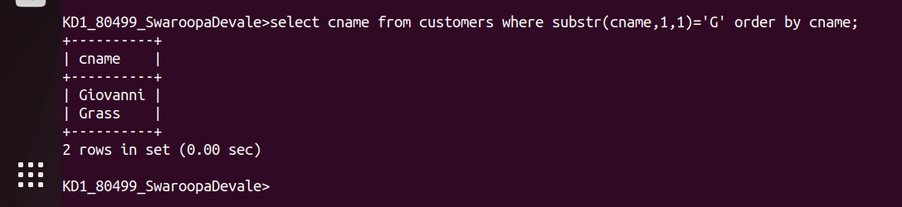

5.
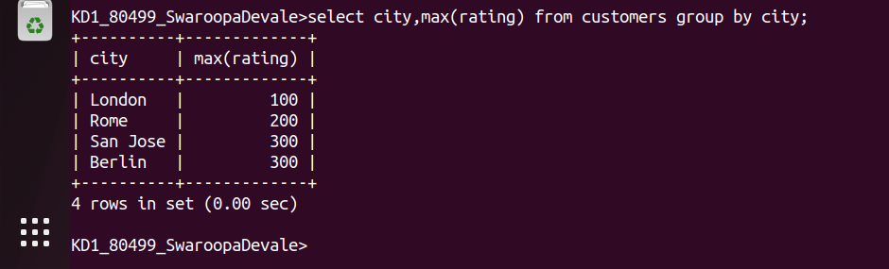

6.

