Assignment-13

Using union clause
1.
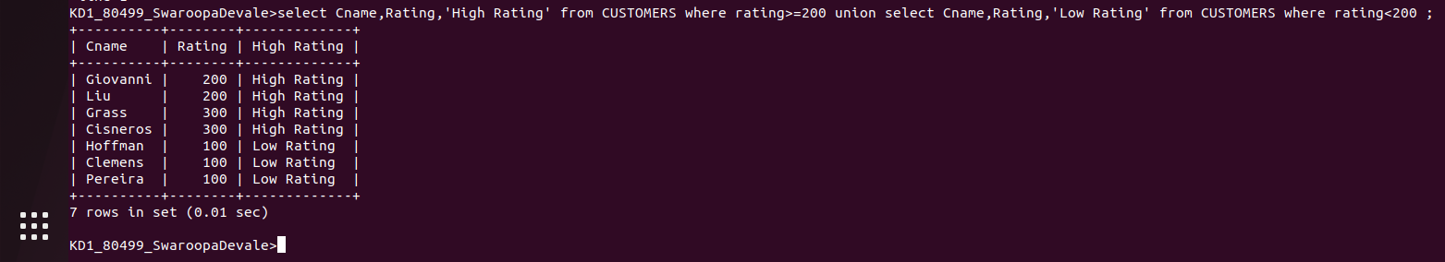
2.
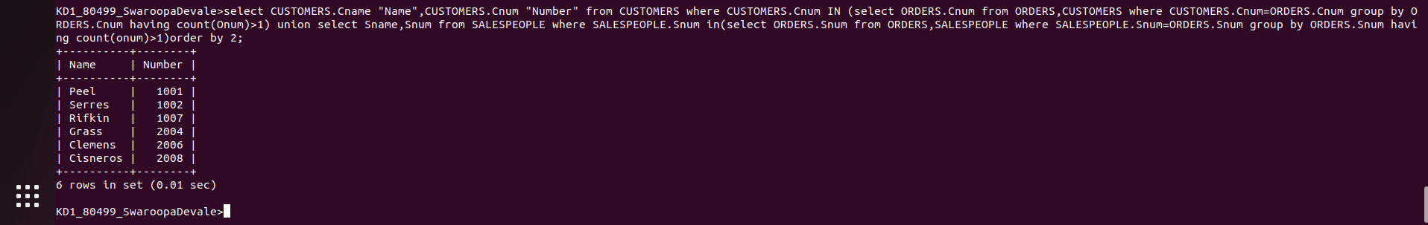
3.
