Assignment-11

Subqueries
1.
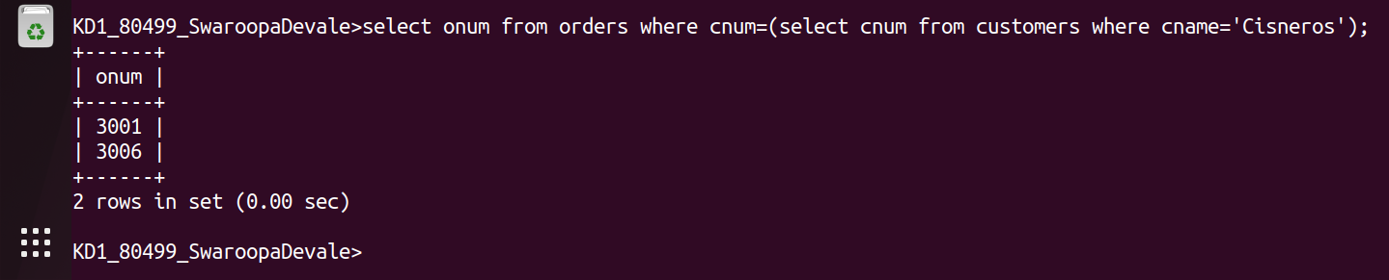
2.
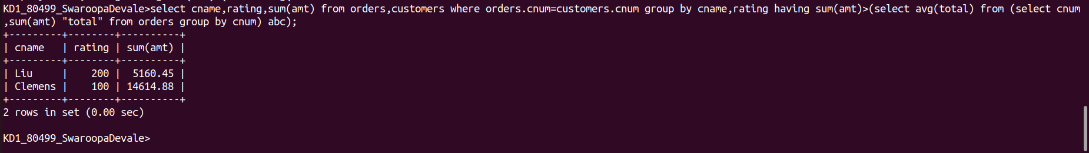
3.
