Assignment-9
Query multiple tables at once
1.
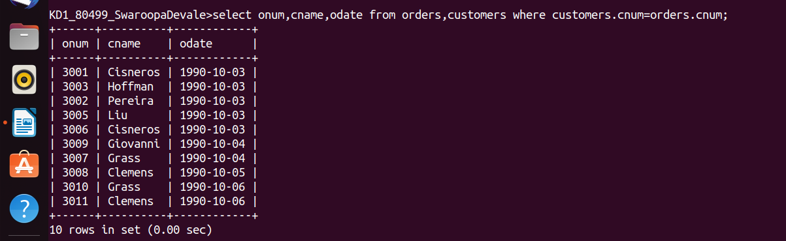

2.
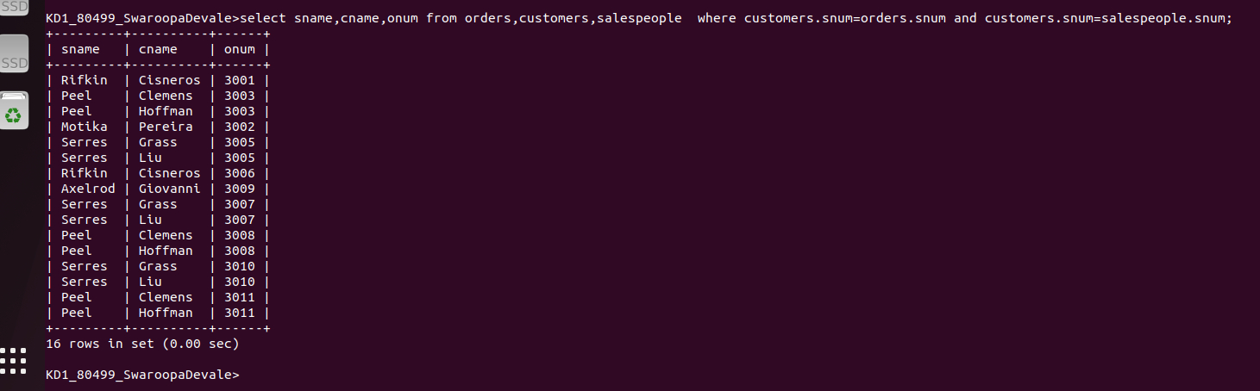

3.

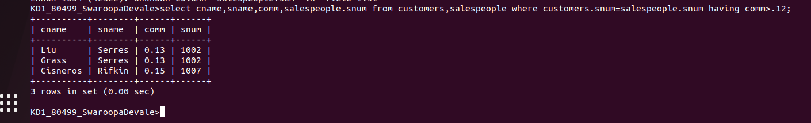
4.

