Assignment-12

Using the operators IN,ANY and ALL
1.
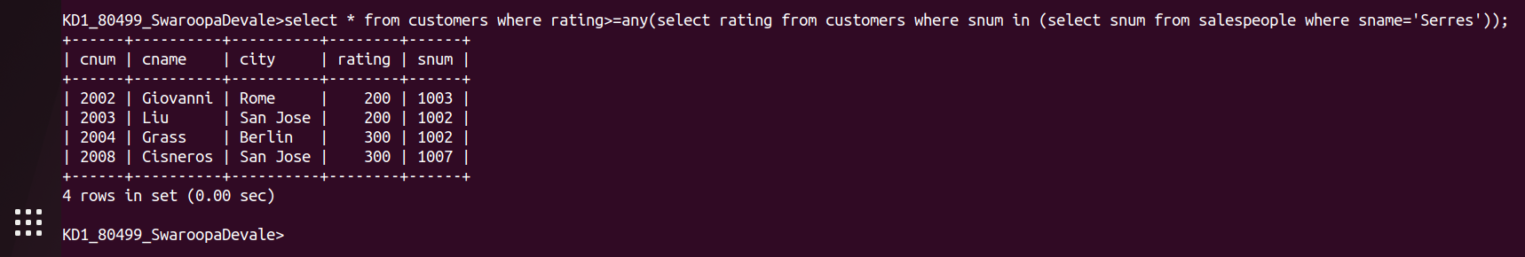
2.
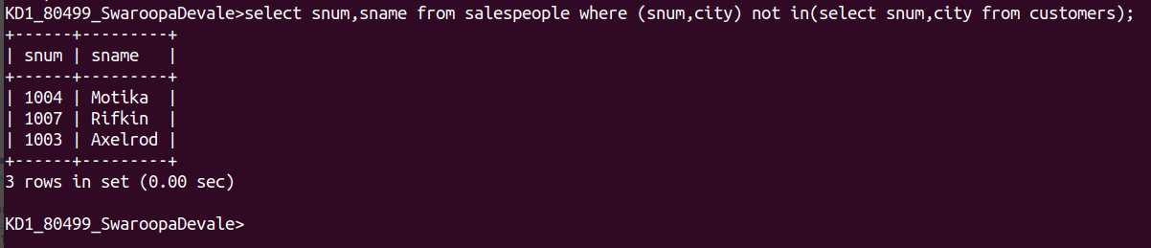
3.
