Assignment-5

Relational and Logical operators

1.
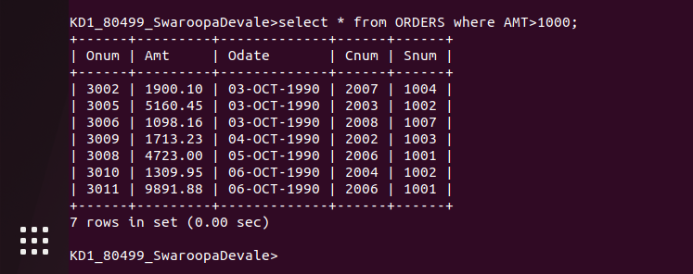

2.
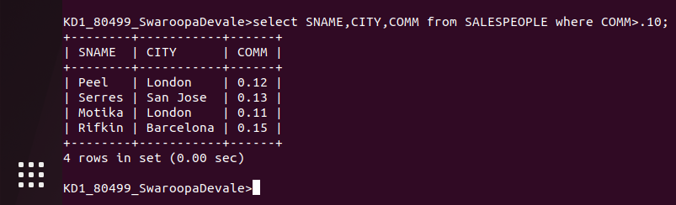

3.


4.


5.
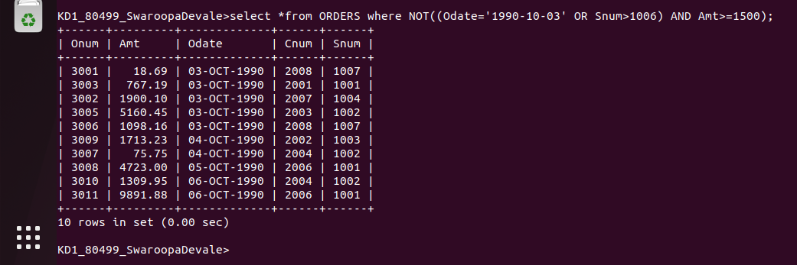

6.

