Assignment-6

Using Special Operators in Conditions

1.
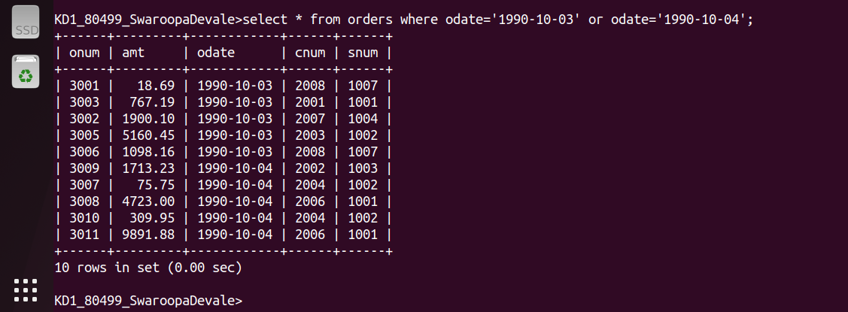
2.
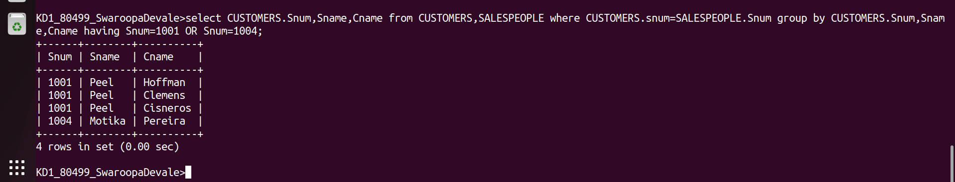
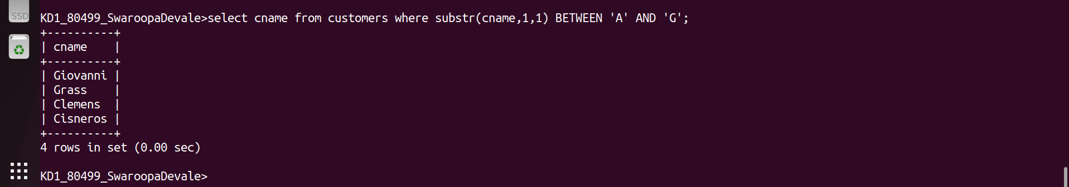
3.
4.
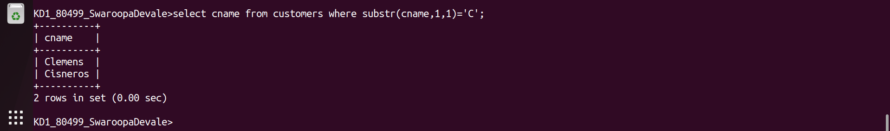
5.
