Assignment-8

Formating Query output

1.
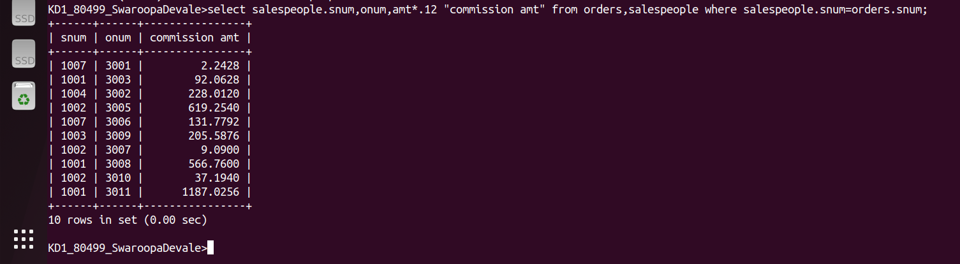
2.

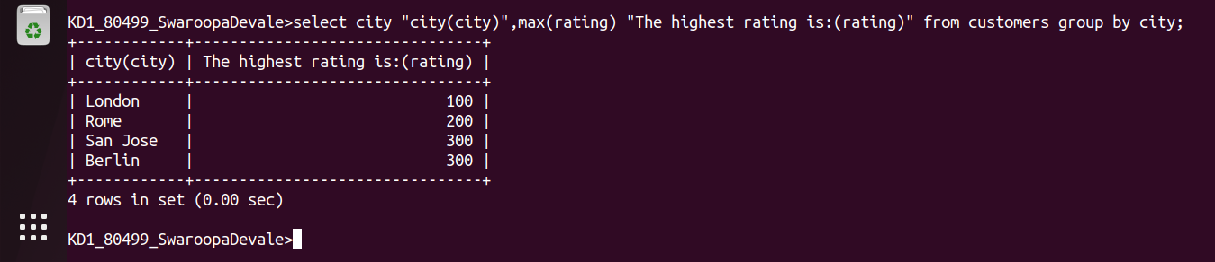
3.
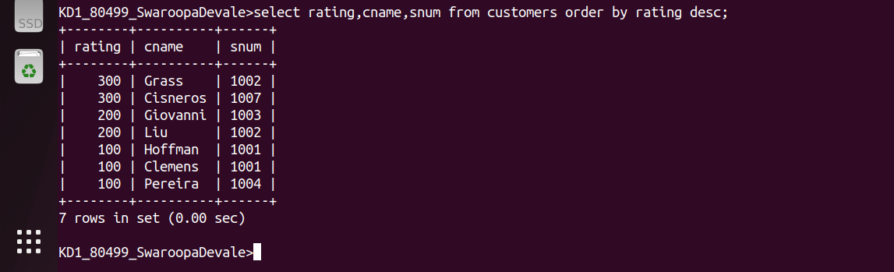
4.

