Assignment-10

Joining a table to itself

1.

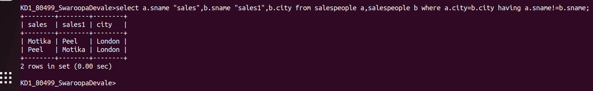
2.

