**Assignment – 6**

Name- Yashraj Ranjeet Shitole

Roll no. - 86633

1) Write two different queries that would produce all orders taken on October 3rd or 4 th, 1990.

**SELECT * FROM Orders WHERE odate=‘1990-10-03’ or odate= ‘1990-10-04' ;**

**SELECT * FROM Orders WHERE odate > ‘1990-10-02’ and odate < ‘1990-10-05’;**

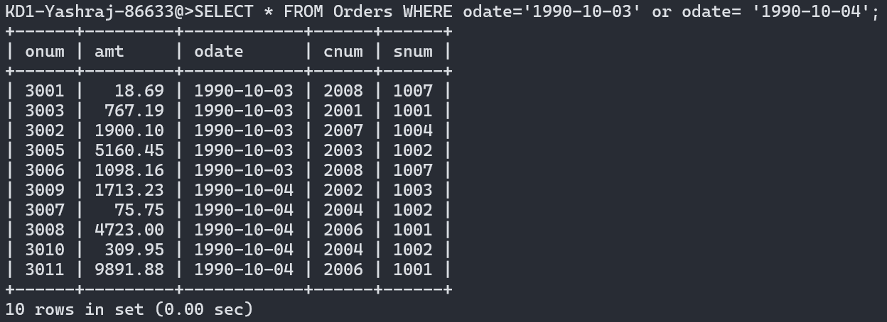

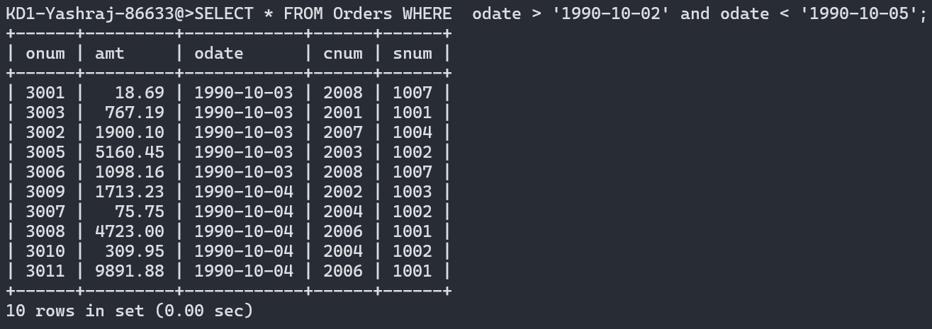

2) Write a query that selects all of the customers serviced by Peel or Motika. (Hint: the snum field relates the two tables to one another).

3) Write a query that will produce all the customers whose names begin with a letter from ‘A’ to ‘G’.

**SELECT * FROM customers WHERE ASCII(cname) > 64 and ASCII(cname) < 72;**

**SELECT * FROM customers WHERE cname BETWEEN 'a' AND 'h';**

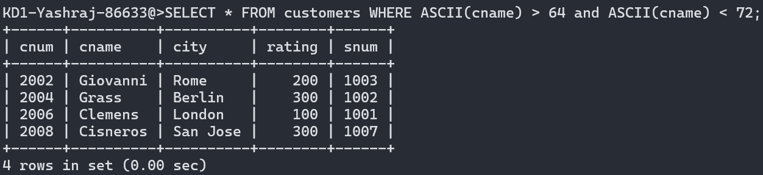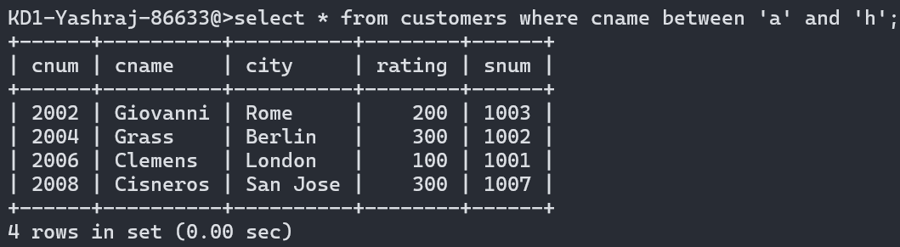

4) Write a query that selects all customers whose names begin with the letter ‘C’.

**SELECT * FROM Customers WHERE cname LIKE 'C%';**

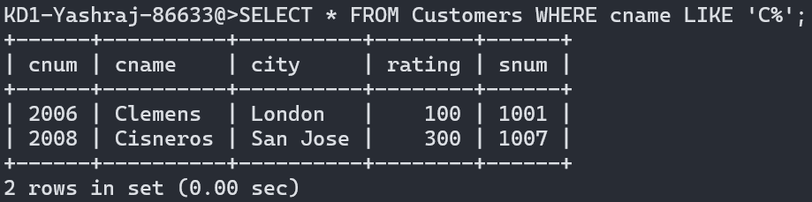

5) Write a query that selects all orders except those with zeroes or NULLs in the amt field.

**SELECT * FROM Orders WHERE amt != null AND amt != 0;**

