**Assignment – 7**

Name- Yashraj Ranjeet Shitole

Roll no. - 86633

1) Write a query that counts all orders for October 3.

**SELECT count(*) FROM Orders WHERE odate = '1990-10-03';**

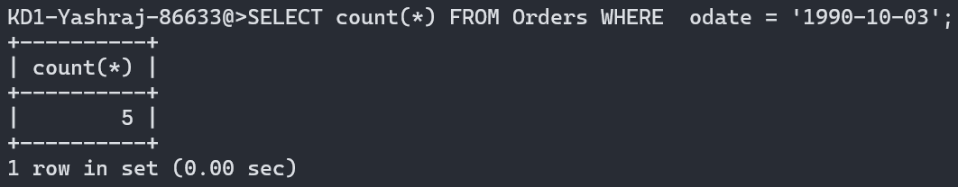

2) Write a query that counts the number of different non-NULL city values in the Customers table.

**SELECT count(*) FROM Customers WHERE city!=null;**

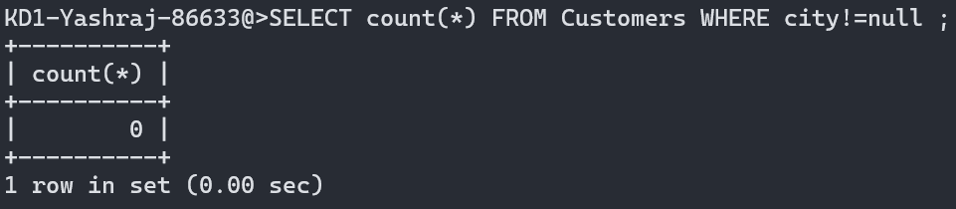

3) Write a query that selects each customer’s smallest order.

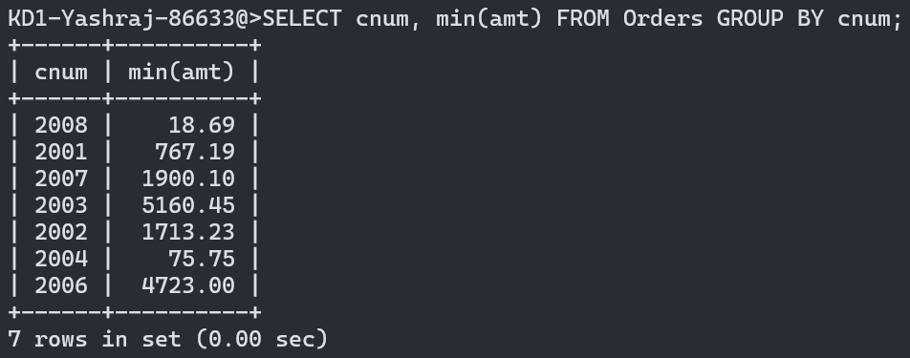

4) Write a query that selects the first customer, in alphabetical order, whose name begins with G.

**SELECT * FROM customers WHERE cname LIKE 'G%' ORDER BY 1 LIMIT 1;**

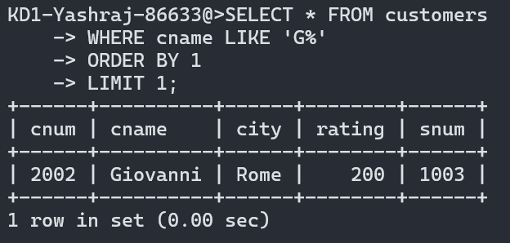

5) Write a query that selects the highest rating in each city.

**SELECT city, MAX(rating) FROM customers GROUP BY city;**

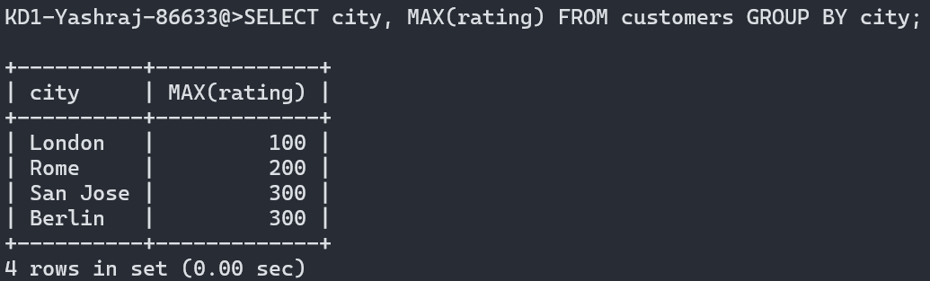

6) Write a query that counts the number of salespeople registering orders for each day. (If a salesperson has more than one order on a given day, he or she should be counted only once.).

**SELECT DISTINCT odate, COUNT(snum) FROM orders GROUP BY odate;**

