**Assignment – 10**

**Joining a Table to Itself**

**1.**

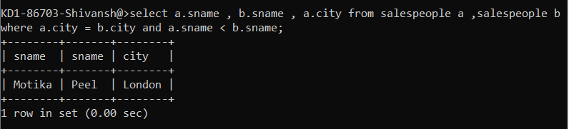

**2.**

