**Assignment – 12**

**Using the operators IN, ANY, and ALL.**

**1.**

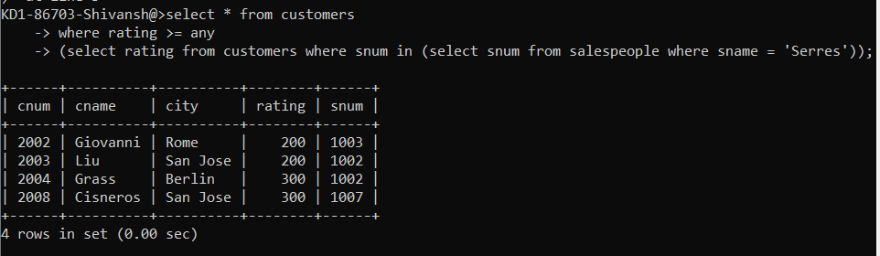

**2.**

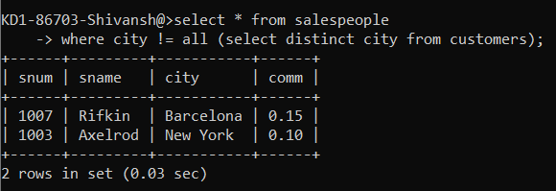

**3.**

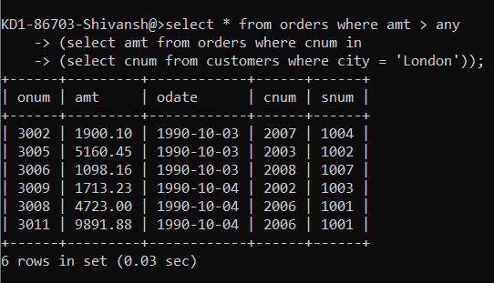

**4.**

