**Assignment – 14**

**Entering, Deleting, and Changing Field Values.**

**1.**

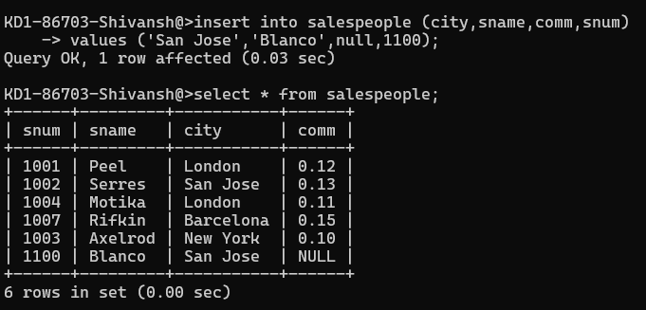

**2.**

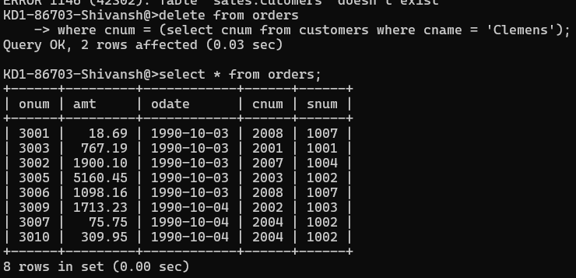

**3.**

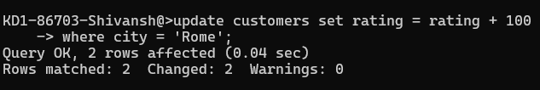

**4.**

