**Assignment – 15**

**Using Subqueries with DML Commands.**

**1.**

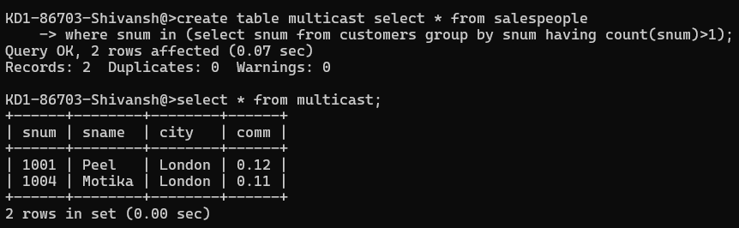

**2.**

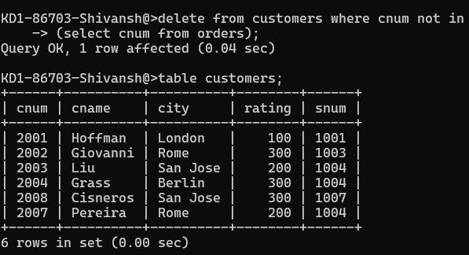

**3.**

