**Assignment –6**

**Using Special Operators in Conditions**.

**1.**

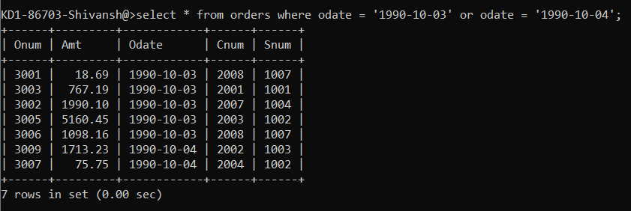

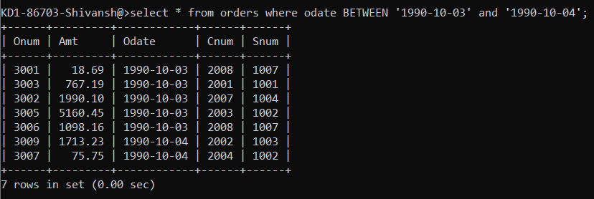

**2.**

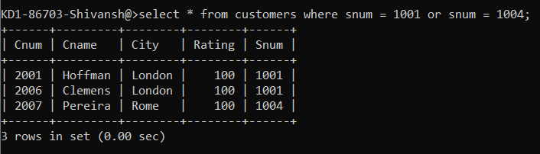

**3.**

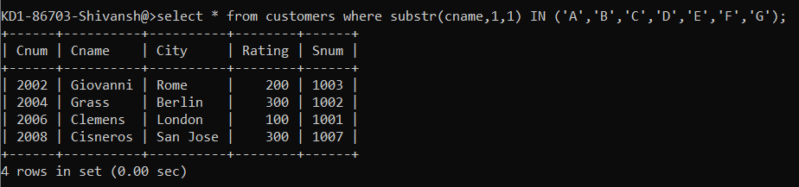

**4.**

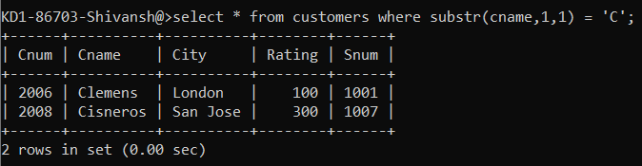

**5.**

