**Assignment –7**

**Summarizing Data with Aggregate Functions.**

**1.**

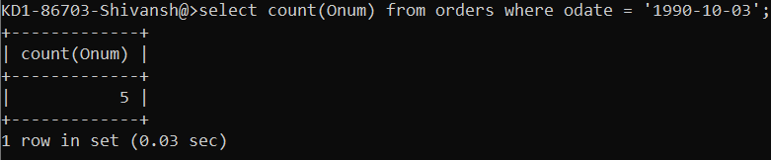

**2.**

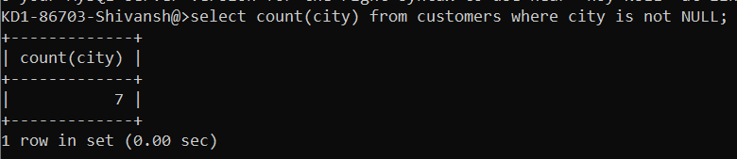

**3.**

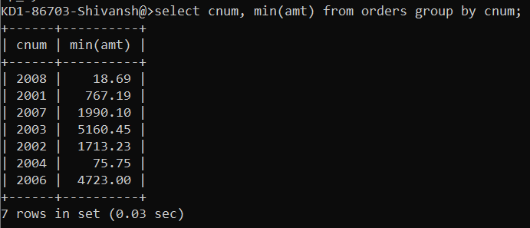

**4.**

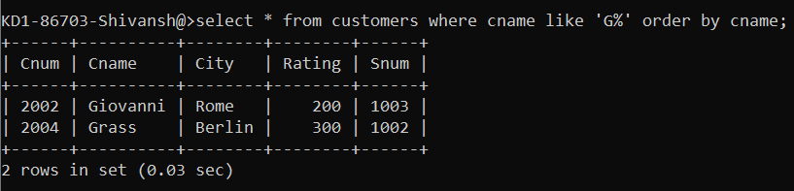

**5.**

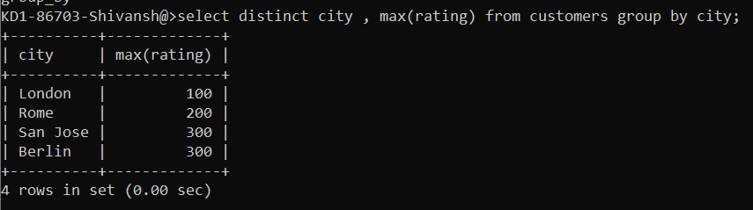

**6.**

