**Assignment – 9**

**Querying Multiple Tables at Once**

**1.**

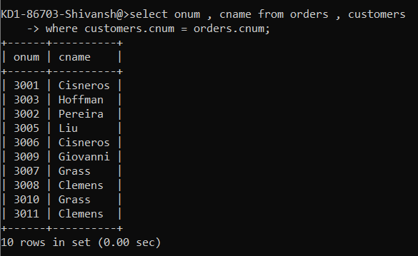

**2.**

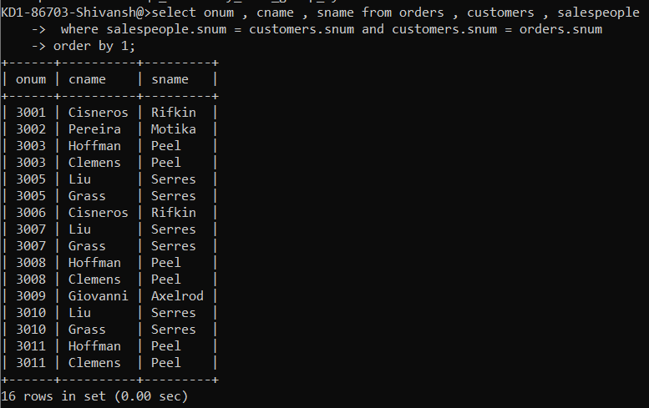

**3.**

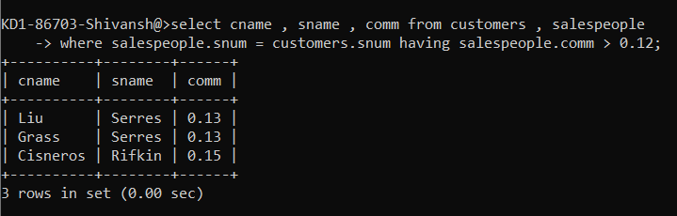

**4.**

