**MartConnect-Smarter Shopping, Better Selling**

## **Introduction**

MartConnect is an online platform that helps **local grocery stores** sell their products online. At the same time, customers can **browse products**, **place orders**, and get groceries **delivered from nearby shops** .

It’s designed to **connect small shop owners and customers** using digital technology. With MartConnect, local sellers who don’t have the resources to create their own website or app can now **easily sell online** with just a few simple steps.

Our goal is to **support small and local businesses**, help them grow digitally, and **give customers a better, faster, and more convenient shopping experience**. MartConnect not only helps customers save time, but also ensures they get **fresh and trusted products** from the stores they already know.It builds a **community connection** — where technology supports local growth, rather than replacing it.

Whether it's daily essentials, snacks, or household items MartConnect makes it all available at your fingertips.

### **Problem Statement**

Let’s first understand the problem:

* Local grocery stores are losing customers to big online apps like Amazon or BigBasket.
* Most small grocery shops don’t have an online system to sell their products.
* Customers enjoy the convenience of online shopping, but also want to support local sellers.
* So, there is a clear gap — and MartConnect is here to bridge that gap.

### 

### **What is MartConnect?**

So, what exactly is MartConnect ?

MartConnect is like an **online marketplace**, but specially designed for **local grocery stores**.

With MartConnect:

* Grocery store owners can **list their products online** and manage their store digitally.
* Customers can **buy daily grocery items easily** from nearby stores.
* Orders are delivered directly to the customer’s doorstep.

It’s simple, smart, and supports local businesses!

### **How MartConnect Works**

#### **For Grocery Store Owners:**

* Register on MartConnect
* Add store details and upload product list
* Start receiving online orders

#### **For Customers:**

* Visit the MartConnect app or website
* Find nearby grocery stores
* Add items to cart and place an order
* Pay online or choose Cash on Delivery.

#### **For Delivery:**

* Orders are delivered either by the store
* Or by **MartConnect’s delivery team.**

**Project Requirements**

Functional Requirements :

### **Customer Side -**

* Register/Login
* Browse stores and products
* Add to cart and place order

### **Seller Side -**

* Register store
* Add/manage products
* View and manage orders

### **Admin Side -**

* Approve seller accounts
* Manage categories and reports

Non-Functional Requirements :

### **Other Requirements -**

* User-friendly interface
* Secure login system
* Mobile and desktop compatible

### 

### **Tech-Stack Used:**

### **Frontend:**

* React JS – for building interactive user interfaces (Admin, Seller, User)
* React Router – for page navigation (routing)
* Axios – for making HTTP requests to the backend
* React Toastify – for notifications (success/error messages)
* CSS / Bootstrap – for styling the UI

### **Backend:**

* Java EE – for creating RESTful APIs
* Servlets / JSP – used in backend logic and page rendering (if any)
* JWT (JSON Web Token) – for secure authentication and role-based access

### **Database:**

* MySQL – for storing user, product, order, and billing data

**UML Diagram:**

1. Admin:

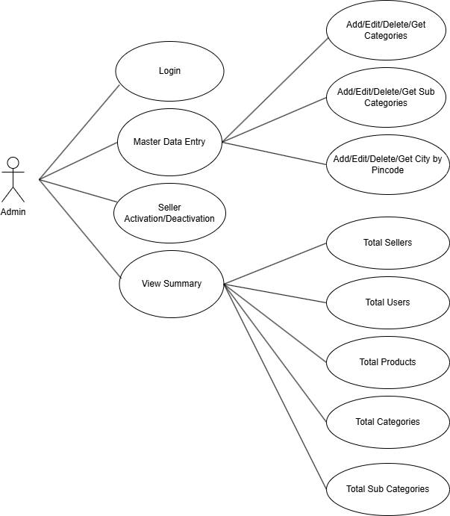

1. Seller:

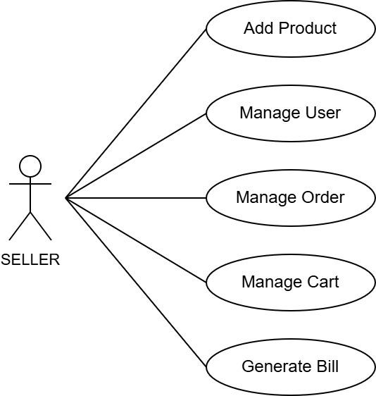

1. Customer:

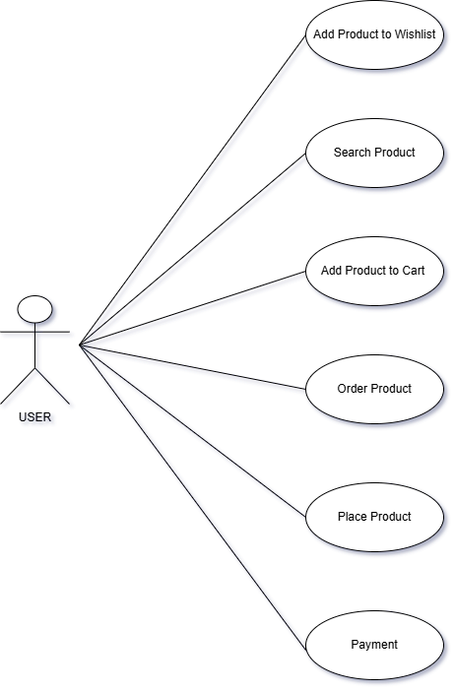

**UI Design:**

1. Master Home Page:

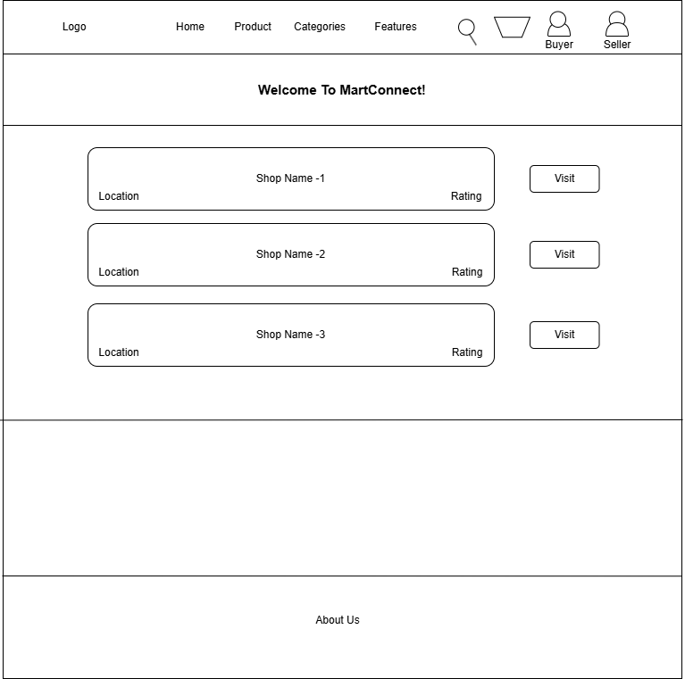

2) Registration/Login Page:

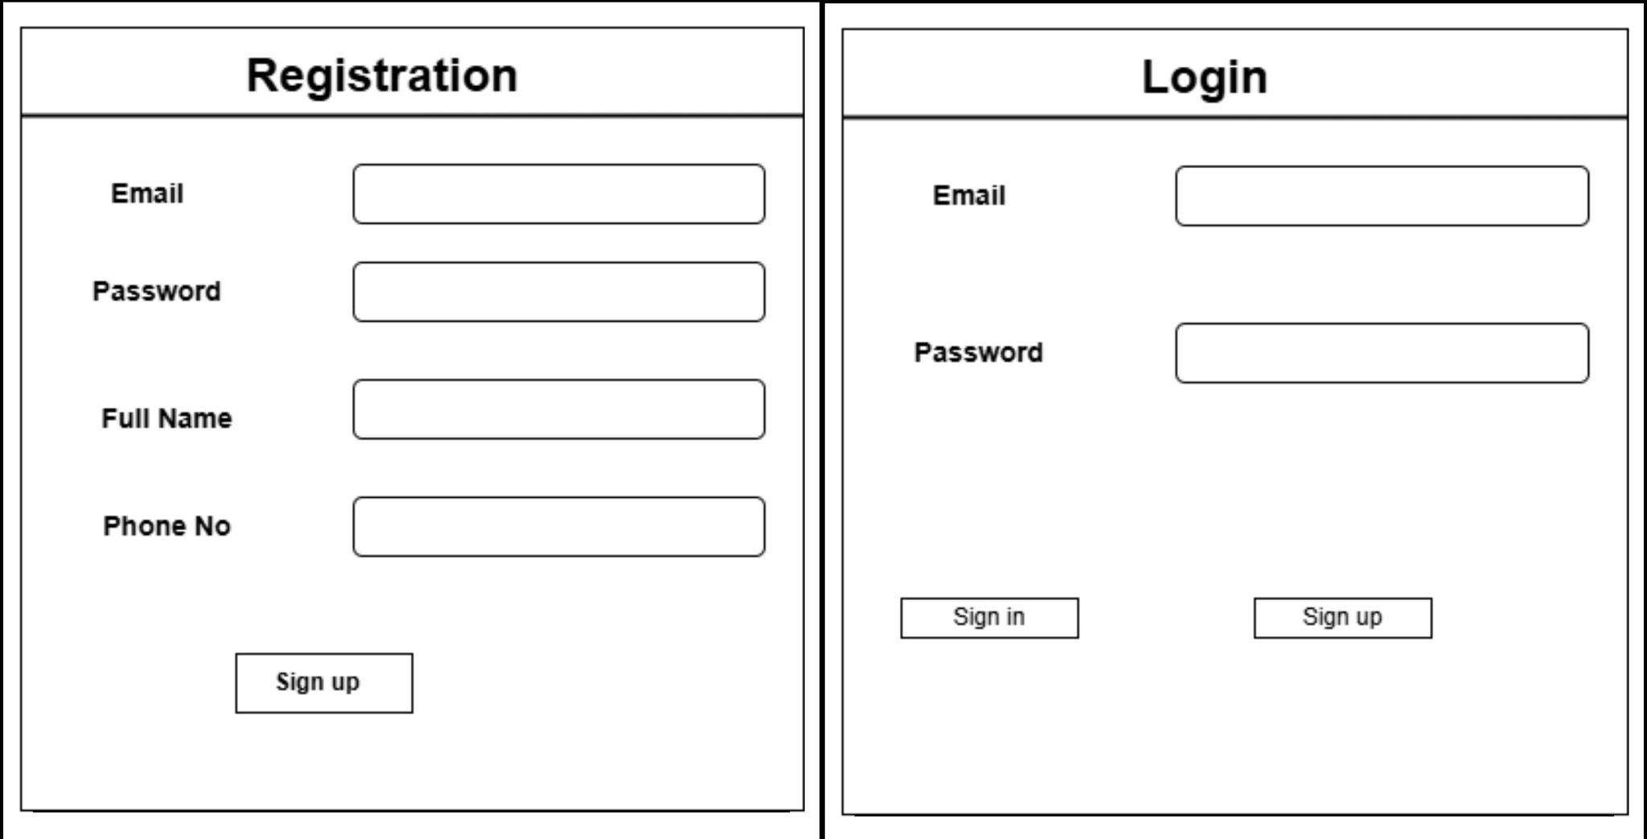

3) Customer Home page :

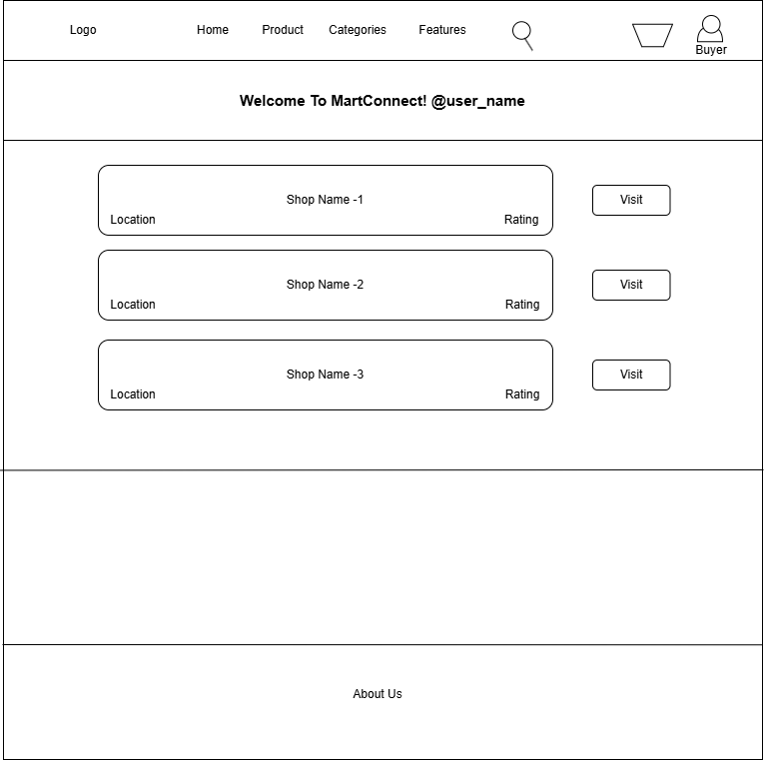

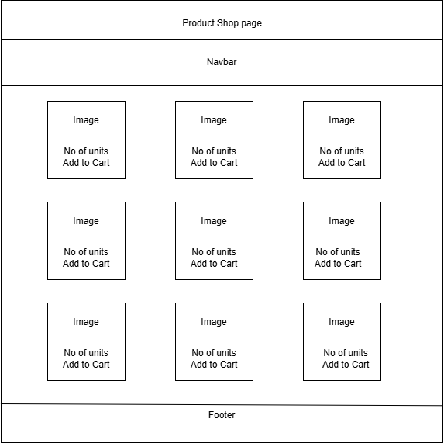

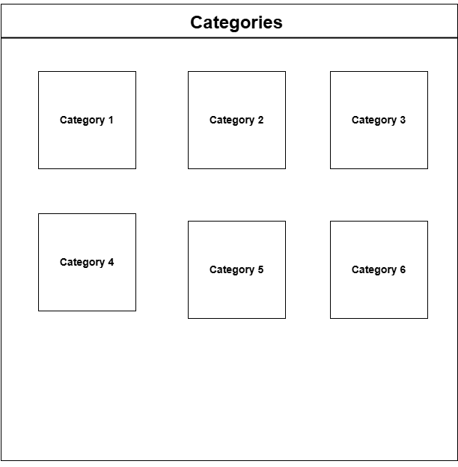

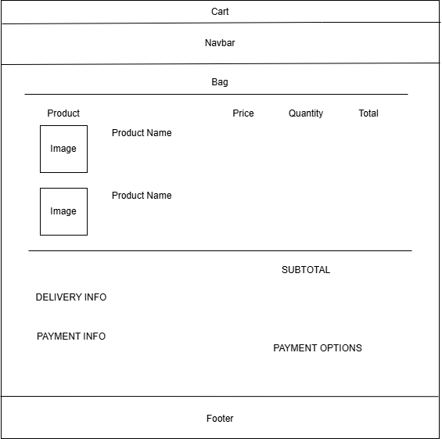

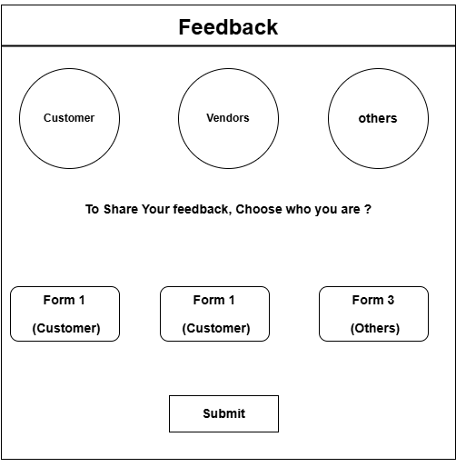

4) Seller:

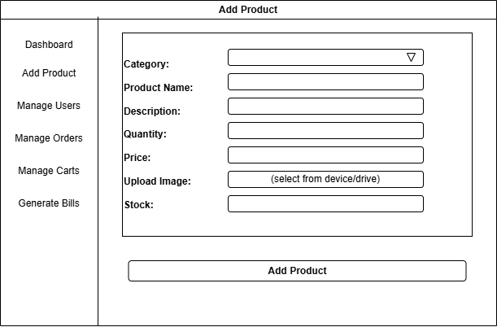

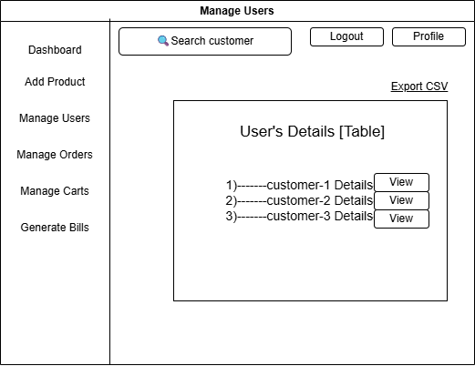

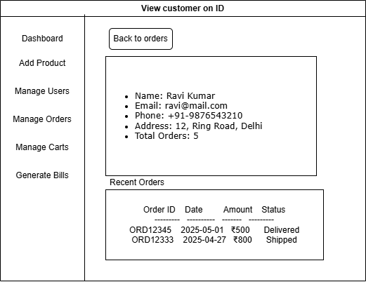

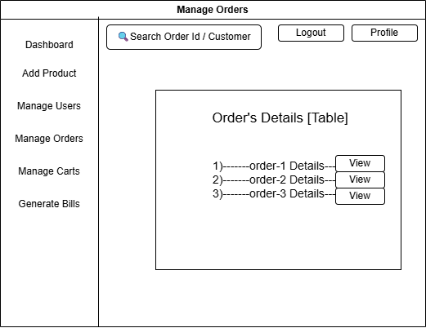

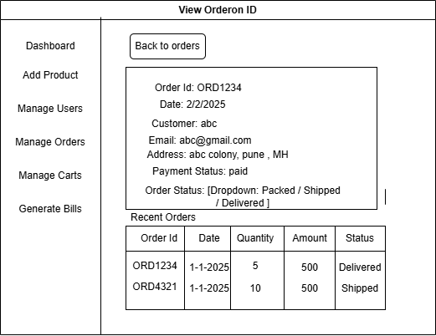

**Database Design:**

