Assignment – 10 Joining a Table to Itself.

1) Write a query that produces all pairs of salespeople who are living in the same city. Exclude combinations of salespeople with themselves as well as duplicate rows with the order reversed.

Asn=

Select s1.sname,s2.sname, s1.city

FROM salespeople s1

INNER JOIN salespeople s2

On s1.city =s2.city

And s1.snum < s2.snum;

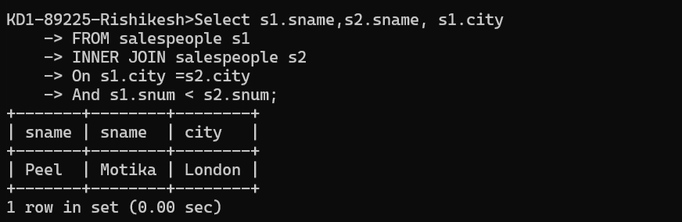

2) Write a query that produces the names and cities of all customers with the same rating as Hoffman.

1st way (SLow)

SELECT * FROM customers

WHERE rating = (SELECT rating FROM customers WHERE cname = 'Hoffman');

**Or**

2nd way (Fast)

