Assignment – 11 Subqueries.

1) Write a query that uses a subquery to obtain all orders for the customer named Cisneros. Assume you do not know his customer number (cnum).

Select * from orders where cnum IN (select cnum from customers where cname= ‘Cisneros’);

**Or**

Select * from orders where cnum = (select cnum from customers where cname= 'Cisneros');

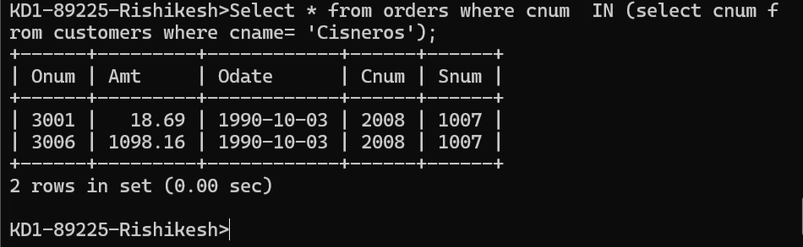

2) Write a query that produces the names and ratings of all customers who have above-average orders.

3) Write a query that selects the total amount in orders for each salesperson for whom this total is greater than the amount of the largest order in the table.

For more information

