–Assignment – 12 Using the operators IN, ANY, and ALL.

1) Write a query that selects all customers whose ratings are equal to or greater than ANY of Serres’.

select \* from customers where rating in (select rating from customers where snum = any(select snum from salespeople where sname = 'Serres'));

2) Write a query using ANY or ALL that will find all salespeople who have no customers located in their city

>select sname from salespeople where city != all(select city from customers);

3) Write a query that selects all orders for amounts greater than any for the customers in London.

Ans select \* from orders where amt > any (select o.amt from orders o,customers c where o.cnum =c.cnum and city = 'London');

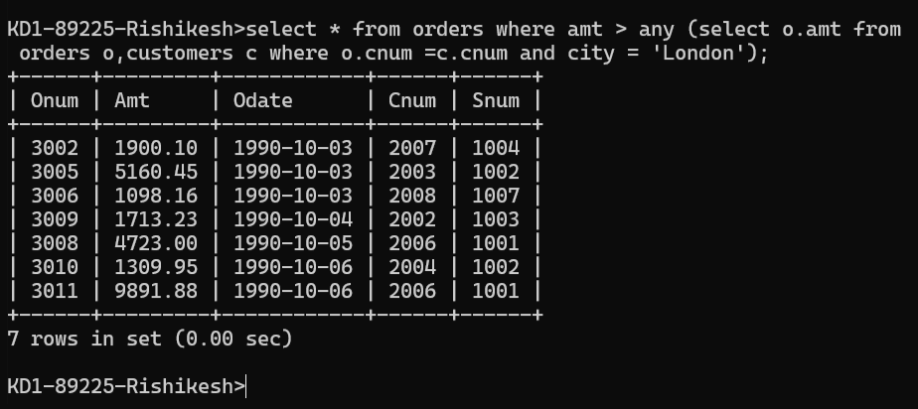

4) Write the above query using MIN or MAX.

Ans = >select \* from orders where amt > (select min(amt) from

orders where amt IN (select o.amt from orders o,customers c where o.cnum =c.cnum and city = 'London'));

