Assignment – 15 Using Subqueries with DML Commands.

1) Assume there is a table called Multicust, with all of the same column definitions as Salespeople. Write a command that inserts all salespeople with more than one customer into this table.

= >CREATE table Multicust (select \* from salespeople where snum IN (select snum from customers group by snum having count(snum)> 1));

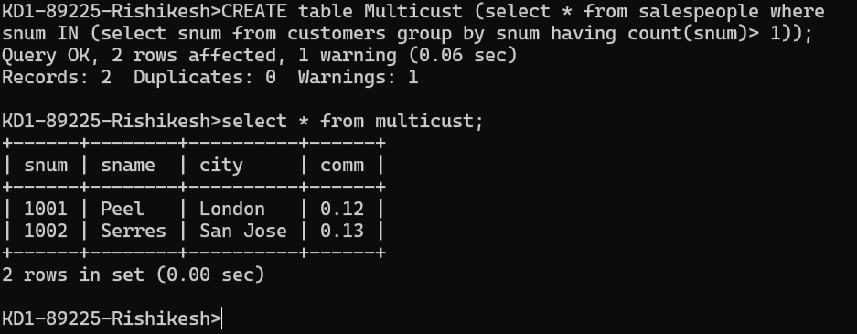

2) Write a command that deletes all customers with no current orders.

Ans = Delete from customers where cnum NOT IN

(Select distinct(cnum) from orders) ;

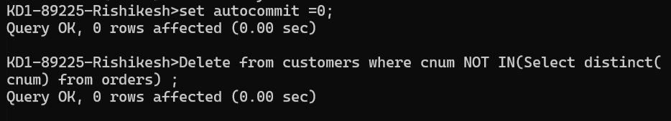

3) Write a command that increases by twenty percent the commissions of all salespeople with total orders above Rs. 3,000.

Ans = update salespeople set comm= comm+ comm\*.2 where snum in(select snum from orders group by snum having sum(amt) > 3000);