**ROLL NO: 89239 GROUP- KD1**

**Assignment – 12 Using the operators**

**IN, ANY, and ALL.**

1. Write a query that selects all customers whose ratings are equal to or greater than ANY of Serres’.

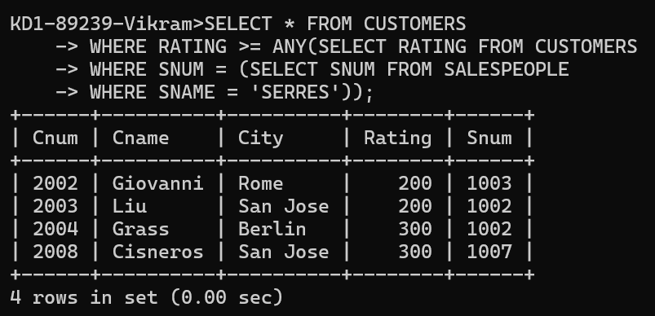

2)Write a query using ANY or ALL that will find all salespeople who have no customers located in their city.

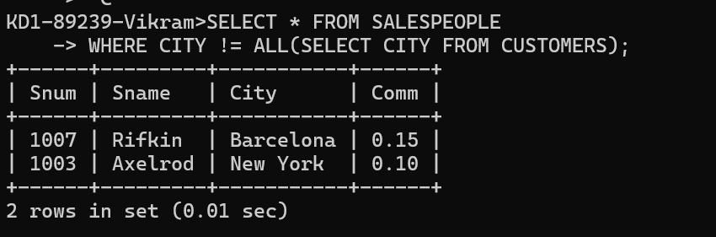

3)Write a query that selects all orders for amounts greater than any for the customers in London.

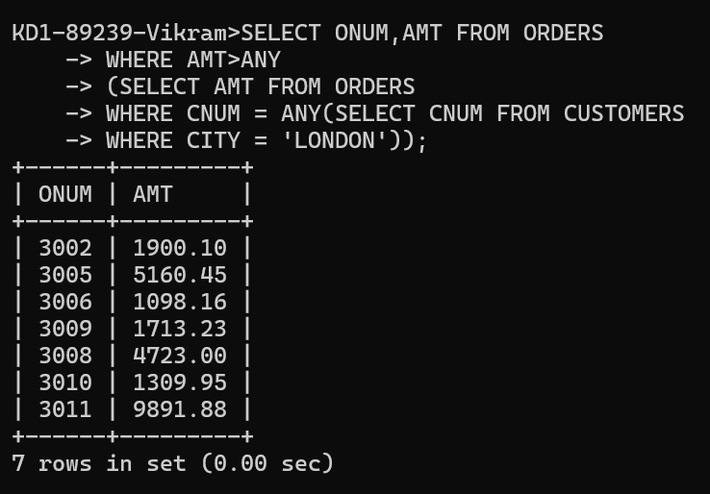

4)Write the above query using MIN or MAX.

