***Assignment – 10***

**Joining a Table to Itself.**

1. Write a query that produces all pairs of salespeople who are living in the same city. Exclude combinations of salespeople with themselves as well as duplicate rows with the order reversed.

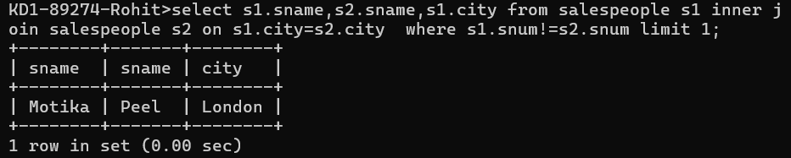

QUERY: select s1.sname, s2.sname,s1.city from salespeople s1 inner join salespeople s2 on s1.city=s2.city where s1.snum!=s2.snum limit 1;

1. Write a query that produces the names and cities of all customers with the same rating as Hoffman.  
   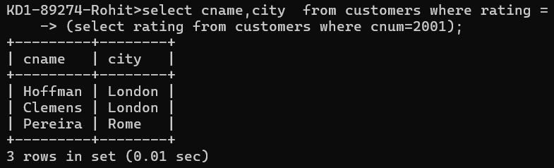   
   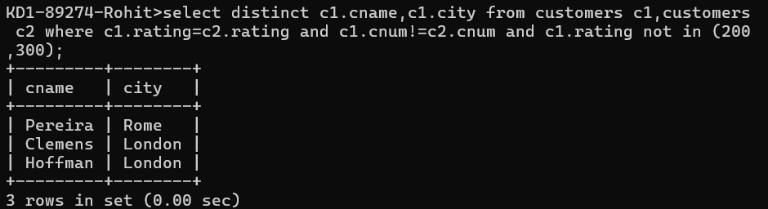  
     
   QUERY: select cname,city from customers where rating =(select rating from customers where cnum=2001);  
     
   QUERY: select distinct c1.cname,c1.city from customers c1,customers c2 where c1.rating=c2.rating and c1.cnum!=c2.cnum and c1.rating not in (200,300);