***Assignment – 11* Subqueries.**

1. Write a query that uses a subquery to obtain all orders for the customer named Cisneros. Assume you do not know his customer number (cnum).   
   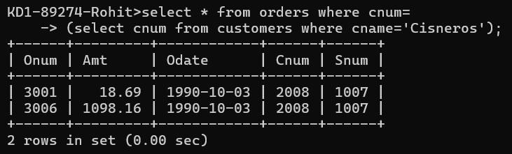  
     
   QUERY: select \* from orders where cnum=

(select cnum from customers where cname='Cisneros');

1. Write a query that produces the names and ratings of all customers who have above-average orders.

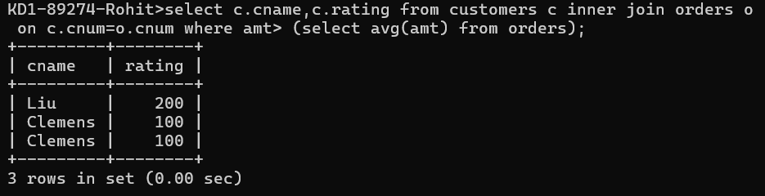

QUERY: select c.cname,c.rating,o.amt from customers c inner join orders o on c.cnum=o.cnum where amt> (select avg(amt) from orders);

1. Write a query that selects the total amount in orders for each salesperson for whom this total is greater than the amount of the largest order in the table.   
   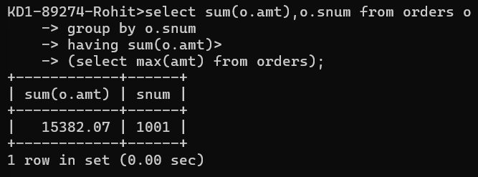

QUERY: select sum(o.amt),o.snum from orders o group by o.snum having sum(o.amt)>(select max(amt) from orders);