***Assignment – 12***

**Using the operators IN, ANY, and ALL.**

1. Write a query that selects all customers whose ratings are equal to or greater than ANY of Serres’.  
     
   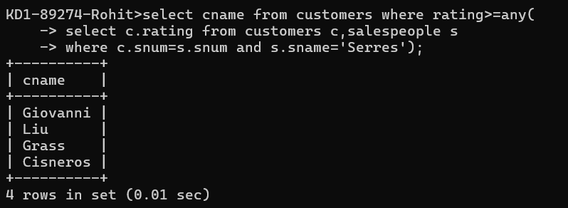

QUERY: select cname from customers where rating>=any (

select c.rating from customers c,salespeople s

where c.snum=s.snum and s.sname='Serres');

1. Write a query using ANY or ALL that will find all salespeople who have no customers located in their city.

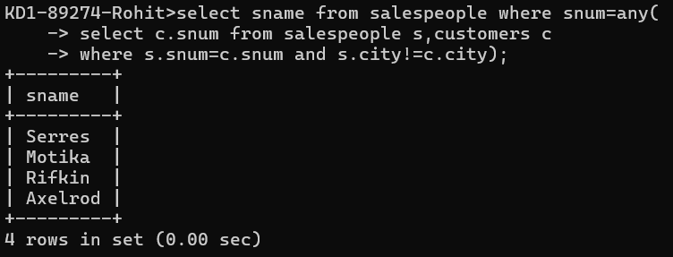

select sname from salespeople where snum=any (

select c.snum from salespeople s,customers c

where s.snum=c.snum and s.city!=c.city);

1. Write a query that selects all orders for amounts greater than any for the customers in London.

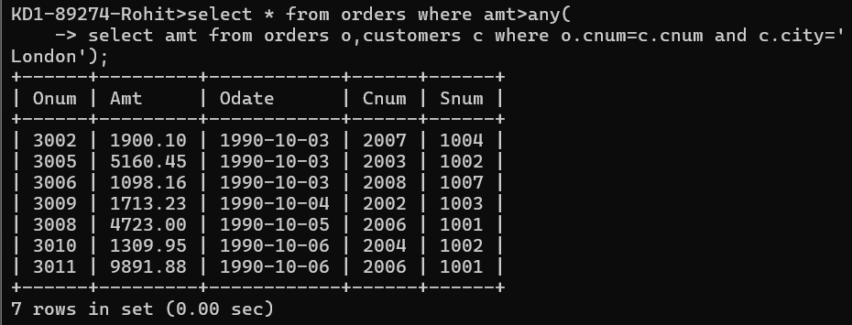

QUERY: select * from orders where amt>any (select amt from orders o,customers c where o.cnum=c.cnum and c.city='London');

1. Write the above query using MIN or MAX.   
     
   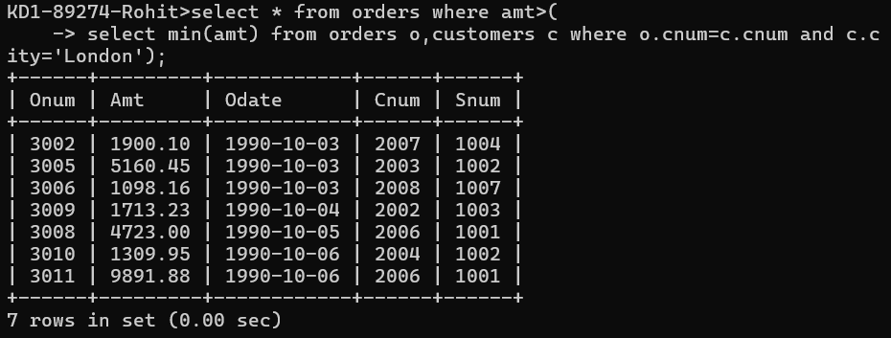  
     
   QUERY: select * from orders where amt> (  
   select min(amt) from orders o,customers c where o.cnum=c.cnum and c.city='London');