***Assignment – 14***

**Entering, Deleting, and Changing Field Values.**

1. Write a command that puts the following values, in their given order, into the salespeople table: city – San Jose, name – Blanco, comm – NULL, cnum – 1100.   
   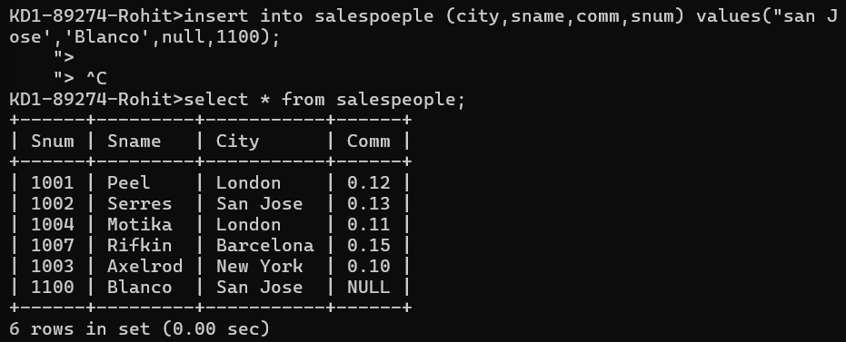  
     
   QUERY: insert into salespoeple (city,sname,comm,snum) values(‘san Jose','Blanco',null,1100);

1. Write a command that removes all orders from customer Clemens from the Orders table.   
   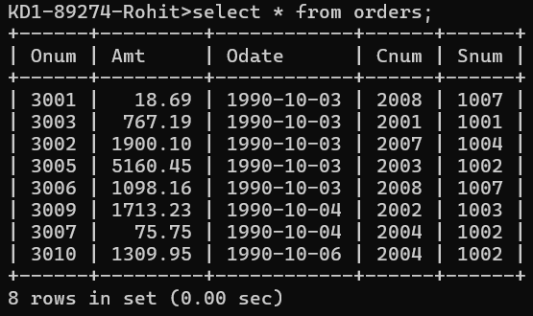

QUERY: delete from orders where cnum=

(select cnum from customers where cname ='Clemens');

1. Write a command that increases the rating of all customers in Rome by 100.   
     
   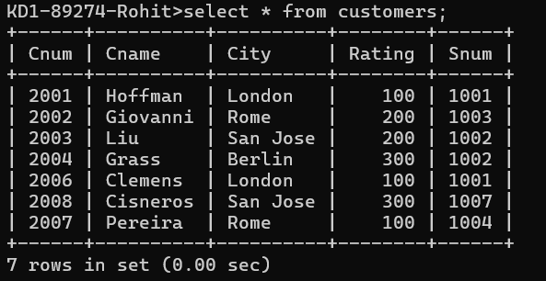

QUERY: update customers set rating=rating +100 where city ='Rome';

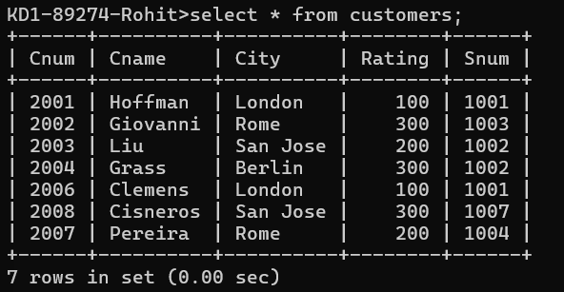

1. Salesperson Serres has left the company. Assign her customers to Motika.

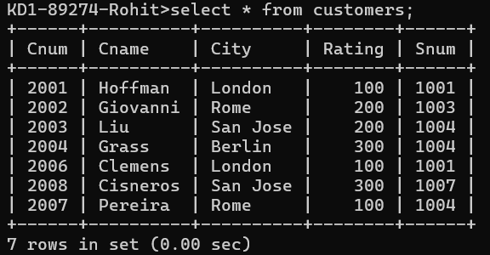  
  
QUERY:   
update customers set snum=(select snum from salespeople where sname='Motika') where snum=(select snum from salespeople where sname='Serres');  
  
