***Assignment – 15***

**Using Subqueries with DML Commands.**

1. Assume there is a table called Multicust, with all of the same column definitions as Salespeople. Write a command that inserts all salespeople with more than one customer into this table.

create table multicast as select * from salespeople where 1=

2;  
 QUERY: insert into multicast (

select * from salespeople where snum in (select snum from customers group by snum having count(city)>1));  
  
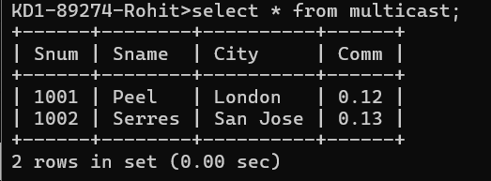

1. Write a command that deletes all customers with no current orders.

QUERY : delete from customers where cnum=(

select * from customers where cnum not in

(select cnum from orders));

1. Write a command that increases by twenty percent the commissions of all salespeople with total orders above Rs. 3,000. 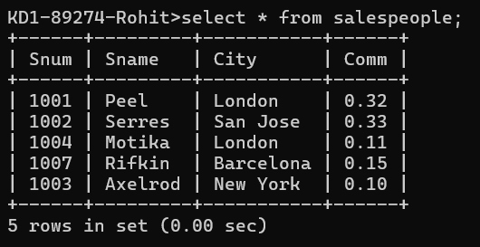  
     
   QUERY: update salespeople set comm=comm+0.20 where snum in(select snum from orders group by snum having sum(amt)>3000);