***Assignment – 16***

**Creating Tables and Indexes.**

1. Write a command that will enable a user to pull orders grouped by date out of the Orders table quickly.   
   QUERY: create index i_order_date_orders on orders (odate ,onum);
2. If the Orders table has already been created, how can you force the onum field to be unique (assume all current values are unique)?   
     
   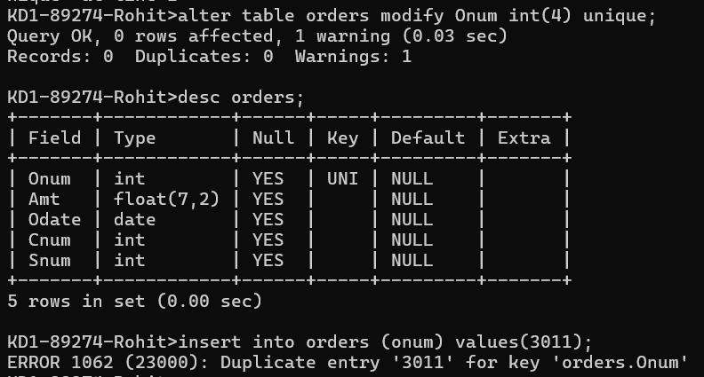  
     
   QUERY: alter table orders modify Onum int(4) unique;

1. Create an index that would permit each salesperson to retrieve his or her orders grouped by date quickly.   
     
   QUERY: create index i_order_date_orders on orders(odate ,snum,onum);

1. Let us assume that each salesperson is to have only one customer of a given rating, and that this is currently the case. Enter a command that enforces it.   
     
   QUERY: create index i_order_date_orders on orders(snum,cnum,rating);