***Assignment – 19* Views.**

1. Create a view that shows all of the customers who have the highest ratings.   
   create view vassign17 as select cnum,cname from customers;  
   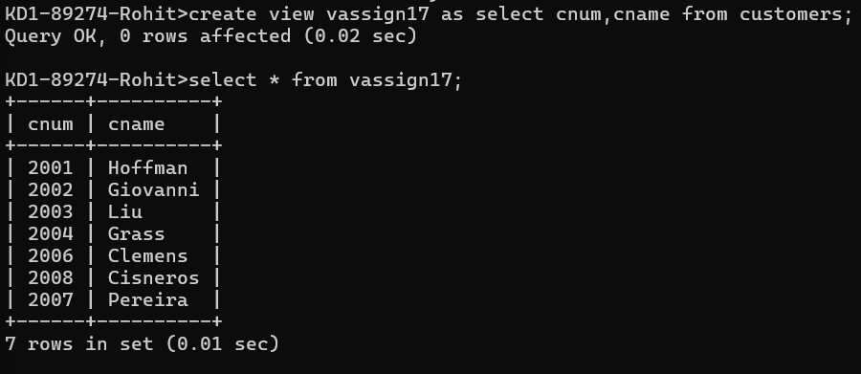

1. Create a view that shows the number of salespeople in each city.   
   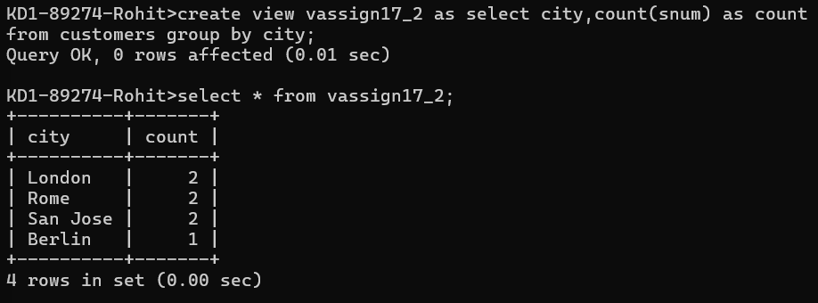  
   create view vassign17_2 as select city,count(snum) as count

from customers group by city;

1. Create a view that shows the average and total orders for each salesperson after his or her name. Assume all names are unique.

1. Create a view that shows each salesperson with multiple customers.   
   select s.sname,c.cname from salespeople s,customers c order by s.sname ;  
   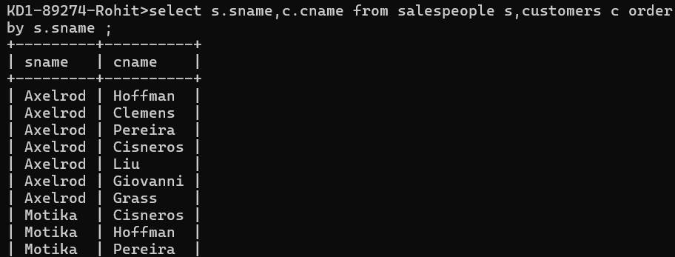

*Sameer Dehadrai* Page: 1