***Assignment –1***

**Creating sample tables and inserting values.**

Create the following tables with the given structures and insert sample data as specified: -

1. *SALESPEOPLE*

Snum int(4)

Sname varchar(10)

City varchar(10)

Comm float(3,2)

1. *CUSTOMERS*

Cnum int(4)

Cname varchar(10)

City varchar(10)

Rating int(4)

Snum int(4)

1. *ORDERS*

Onum int(4)

Amt float(7,2) Odate date

Cnum int(4)

Snum int(4)

*SALES PEOPLE*

|  |  |  |  |
| --- | --- | --- | --- |
| SNUM | SNAME | CITY | COMM |
| 1001 | Peel | London | .12 |
| 1002 | Serres | San Jose | .13 |
| 1004 | Motika | London | .11 |
| 1007 | Rifkin | Barcelona | .15 |
| 1003 | Axelrod | New York | .10 |

*Sameer Dehadrai Page:* ***1***

*CUSTOMERS*

|  |  |  |  |  |
| --- | --- | --- | --- | --- |
| CNUM | CNAME | CITY | RATING | SNUM |
| 2001 | Hoffman | London | 100 | 1001 |
| 2002 | Giovanni | Rome | 200 | 1003 |
| 2003 | Liu | San Jose | 200 | 1002 |
| 2004 | Grass | Berlin | 300 | 1002 |
| 2006 | Clemens | London | 100 | 1001 |
| 2008 | Cisneros | San Jose | 300 | 1007 |
| 2007 | Pereira | Rome | 100 | 1004 |

*ORDERS*

|  |  |  |  |  |
| --- | --- | --- | --- | --- |
| ONUM | AMT | ODATE | CNUM | SNUM |
| 3001 | 18.69 | 03-OCT-1990 | 2008 | 1007 |
| 3003 | 767.19 | 03- OCT -1990 | 2001 | 1001 |
| 3002 | 1900.10 | 03- OCT -1990 | 2007 | 1004 |
| 3005 | 5160.45 | 03- OCT -1990 | 2003 | 1002 |
| 3006 | 1098.16 | 03- OCT -1990 | 2008 | 1007 |
| 3009 | 1713.23 | 04- OCT -1990 | 2002 | 1003 |
| 3007 | 75.75 | 04- OCT -1990 | 2004 | 1002 |
| 3008 | 4723.00 | 05- OCT -1990 | 2006 | 1001 |
| 3010 | 1309.95 | 06- OCT -1990 | 2004 | 1002 |
| 3011 | 9891.88 | 06- OCT -1990 | 2006 | 1001 |

*Sameer Dehadrai Page:* ***2***

***ANSWER :***

*a.* select * from salespeople;

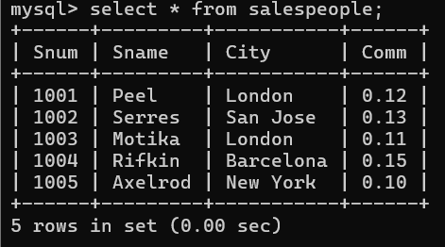

b.

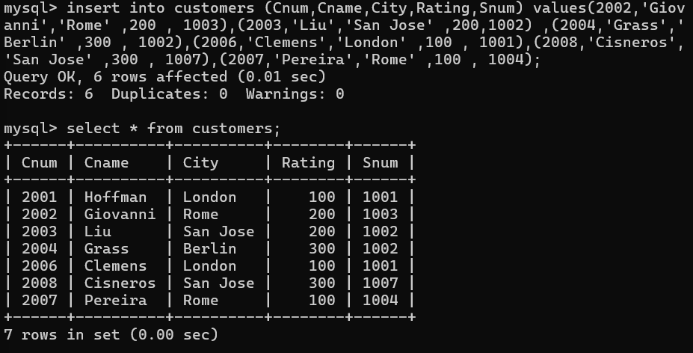

QUERY:

create table customers(

Cnum int(4) ,

Cname varchar(10) ,

City varchar(10) ,

Rating int(4) ,

Snum int(4) );

insert into customers (Cnum,Cname,City,Rating,Snum)

values (2001, 'Hoffman','London' ,100 , 1001),

(2002,'Giovanni','Rome' ,200 , 1003),

(2003,'Liu','San Jose' ,200,1002) ,

(2004,'Grass','Berlin' ,300 , 1002),

(2006,'Clemens','London' ,100 , 1001),

(2008,'Cisneros','San Jose' ,300 , 1007),

(2007,'Pereira','Rome' ,100 , 1004);

c.

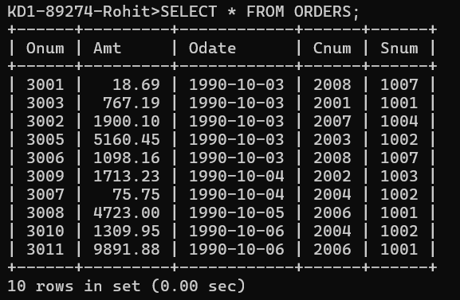

Query: create table orders ( Onum int(4) ,

Amt float(7,2) ,

Odate date ,

Cnum int(4) ,

Snum int(4) );

insert into orders (Onum,Amt,Odate,Cnum,Snum)

Values(3001 , 18.69 , '1990-10-03' , 2008 , 1007),

(3003 , 767.19 , '1990-10-03' , 2001 , 1001),

(3002 , 1900.10 , '1990-10-03' , 2007 , 1004),

(3005 , 5160.45 , '1990-10-03' , 2003 , 1002),

(3006 , 1098.16 , '1990-10-03' , 2008 , 1007),

(3009 , 1713.23 , '1990-10-04' , 2002 , 1003),

(3007 , 75.75 , '1990-10-04' , 2004 , 1002),

(3008 , 4723.00 , '1990-10-05' , 2006 , 1001),

(3010 , 1309.95 , '1990-10-06' , 2004 , 1002),

(3011 , 9891.88 , '1990-10-06' , 2006 , 1001);