***Assignment – 20* Changing Values through Views.**

1. Which of these views are updateable (will allow DML operations)?

|  |  |
| --- | --- |
| #1 | Create View Dailyorders |
|  | as Select Distinct cnum, snum, onum, odate from Orders; |
| #2 | Create View Custotals |
|  | as Select cname, Sum (amt) Sum_Amt from Orders, Customers  where Orders.cnum=Customers.cnum Group by cname; |
| #3 | Create view Thirdorders |
|  | as Select * from Dailyorders where odate=’1990-10-03’; |
| #4 | Create view Nullcities |
|  | as Select snum, sname, city  from Salespeople where city is NULL  OR sname BETWEEN ‘A’ and ‘MZ’; |

This view is updatable as,

Based on a single table (Salespeople).

No DISTINCT, GROUP BY, or Aggregate Functions.

Only Uses a WHERE Clause, which doesn't prevent updates.

1. Create a view of the Salespeople table called Commissions. This view will include only the snum and comm fields. Through this view, someone could enter or change commissions, but only to values between .10 and .20.

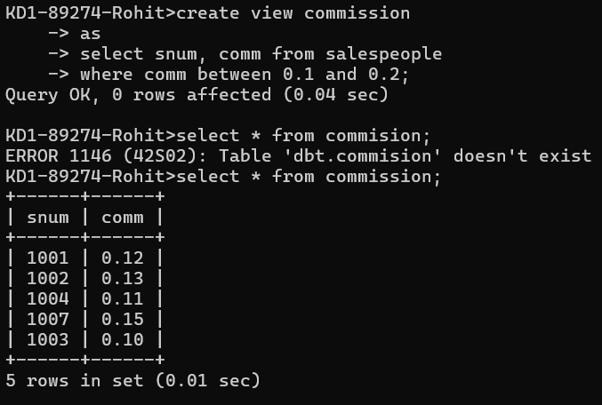  
  
create view commission

as

select snum, comm from salespeople

where comm between 0.1 and 0.2;

1. Some SQL implementations have a built-in constant representing the current date, sometimes called “CURDATE” or “SYSDATE”. The word SYSDATE can therefore be used in a SQL statement, and be replaced by the current date when the value is accessed by commands such as Select or Insert. We will use a view of the Orders table called Entryorders to insert rows into the Orders table. Create the Orders table, so that SYSDATE is automatically inserted for odate if no value is given. Then create the Entryorders view so that no values can be given.   
   Create table Entryorders(

Onum int primary key,

Amt float(7,2),

Cnum int not null,

Snum int not null,

Odate date default sysdate()

);

Create view Entryorders

As

Select * from Entryorders;