***Assignment –4***

**Retrieving Information from Tables.**

1. Write a select command that produces the order number, amount, and date for all rows in the Orders table.

ANS:

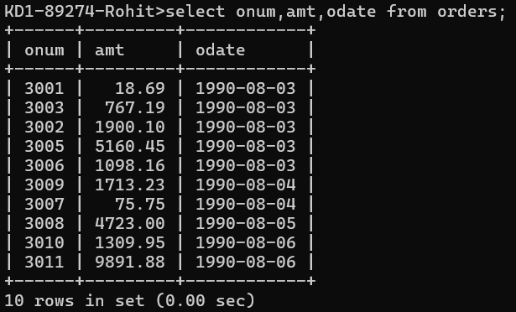

Query:

select onum,amt,odate from orders;

1. Write a query that produces all rows from the Customers table for which the salesperson’s number is 1001.

ANS:

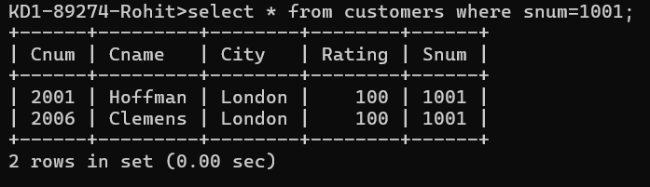

QUERY:

select * from customers where snum=1001;

1. Write a query that displays the Salespeople table with the columns in the following order: city, sname, snum, comm.

ANS:

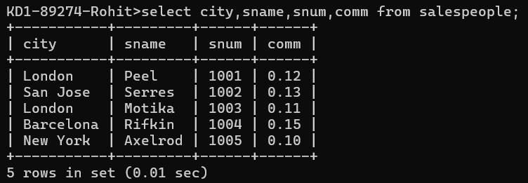

QUERY:

select city,sname,snum,comm from salespeople;

1. Write a select command that produces the rating followed by the name of each customer in San Jose.

ANS:

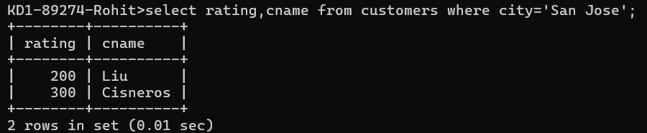

QUERY:

select rating,cname from customers where city='San Jose';

1. Write a query that will produce the snum values of all salespeople (suppress the duplicates) with orders in the Orders table.  
   ANS:  
   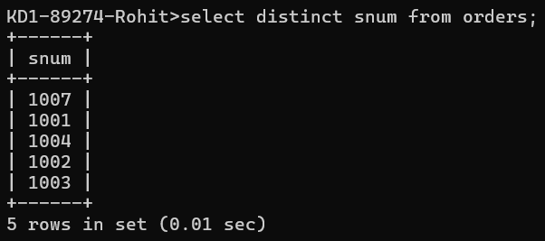

QRERY: select distinct snum from orders;