***Assignment –6***

**Using Special Operators in Conditions.**

1. Write two different queries that would produce all orders taken on October 3rd or 4th, 1990.

ANS:

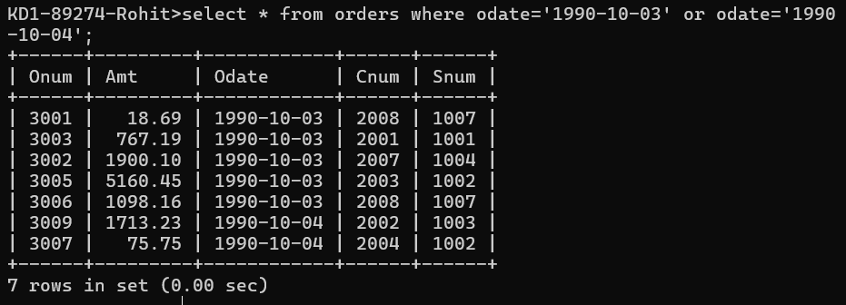

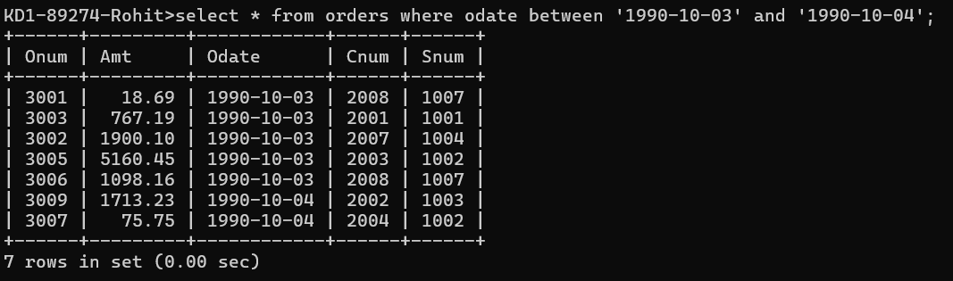

QUERY1: SELECT * FROM ORDERS WHERE ODATE='1990-10-03' AND ODATE='1990-10-04';

QUERY2: SELECT * FROM ORDERS WHERE ODATE BETWEEN '1990-10-03' AND '1990-10-04';

1. Write a query that selects all of the customers serviced by Peel or Motika. (Hint: the snum field relates the two tables to one another).   
   ANS:

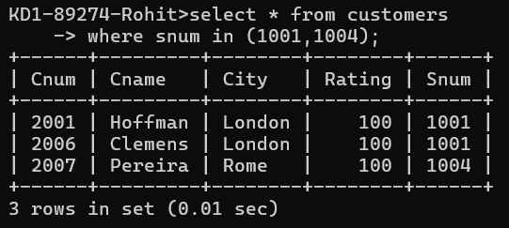

QUERY: SELECT * FROM CUSTOMERS

WHERE SNUM IN (1001,1004);

1. Write a query that will produce all the customers whose names begin with a letter from ‘A’ to ‘G’.

ANS: 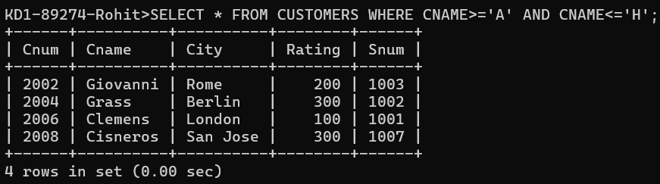

QUERY: SELECT * FROM CUSTOMERS WHERE CNAME>='A' AND CNAME<='H';

SELECT * FROM CUSTOMERS WHERE CNAME>='A' AND CNAME<='G';(Names starting with G is not included).

1. Write a query that selects all customers whose names begin with the letter ‘C’.   
   ANS: 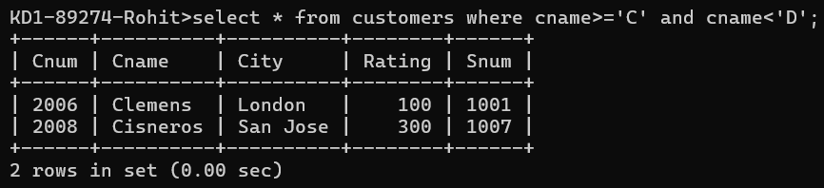

QUERY: SELECT * FROM CUSTOMERS WHERE CNAME>='C' AND CNAME<'D';

1. Write a query that selects all orders except those with zeroes or NULLs in the amt field.

ANS:

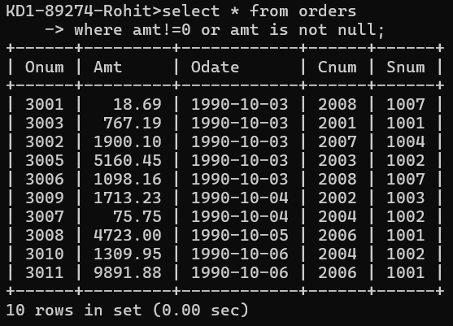

QUERY: SELECT * FROM ORDERS

WHERE AMT!=0 OR AMT IS NOT NULL;