***Assignment –7***

**Summarizing Data with Aggregate Functions.**

1. Write a query that counts all orders for October 3.

ANS:

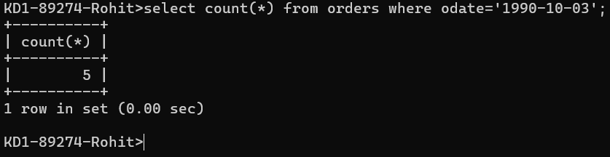

Query: select count(*) from orders where odate='1990-10-03';se

1. Write a query that counts the number of different non-NULL city values in the Customers table.

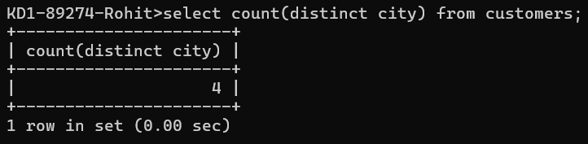

QUERY: select count(distinct city) from customers; //count ignores null value.

1. Write a query that selects each customer’s smallest order.

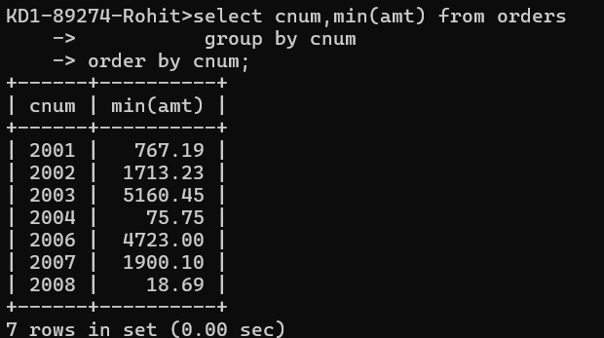

QUERY: select cnum,min(amt) from orders

group by cnum

order by cnum;

1. Write a query that selects the first customer, in alphabetical order, whose name begins with G.

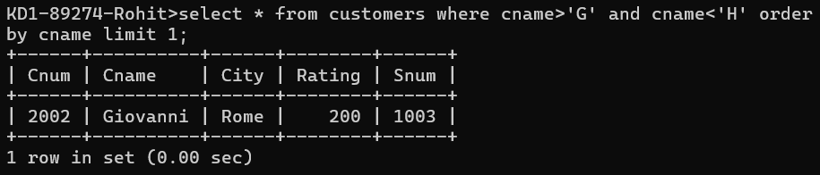

1. Write a query that selects the highest rating in each city.

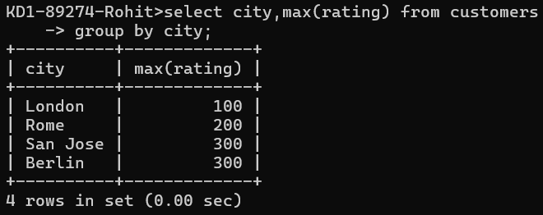

QUERY: select city, max(rating) from customers

group by city;

1. Write a query that counts the number of salespeople registering orders for each day. (If a salesperson has more than one order on a given day, he or she should be counted only once.). 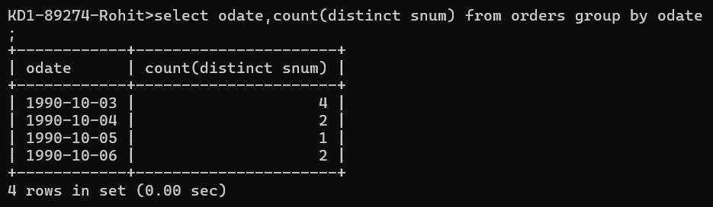  
     
   QUERY : select odate, count(distinct snum) from orders group by odate;