***Assignment –8***

**Formatting Query output.**

1. Assume each salesperson has a 12% commission. Write a query on the orders table that will produce the order number, the salesperson number, and the amount of the salesperson’s commission for that order.

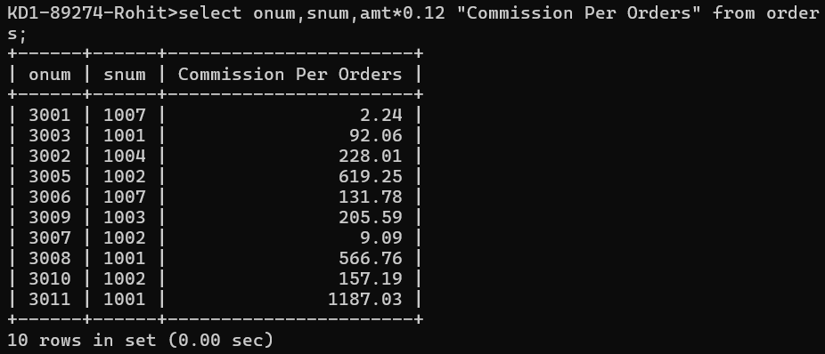

QUERY: select onum,snum,amt*0.12 "Commission Per Orders" from orders;

1. Write a query on the Customers table that will find the highest rating in each city. Put the output in this form:

For the city (city), the highest rating is : (rating).

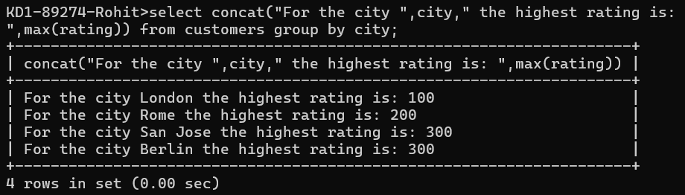

QUERY : select concat("For the city ",city," the highest rating is: ",max(rating)) from customers group by city;

1. Write a query that lists customers in descending order of rating. Output the rating field first, followed by the customer’s name and number.

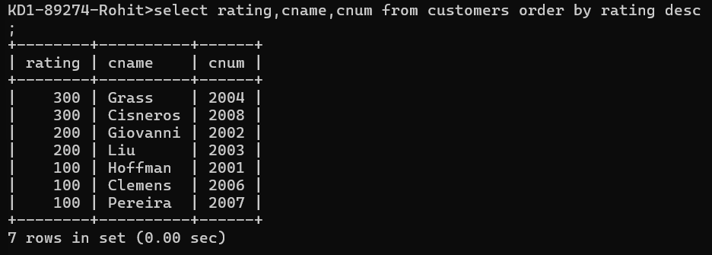

QUERY: select rating,cname,cnum from customers order by rating desc;

1. Write a query that totals the orders for each day and places the results in descending order. 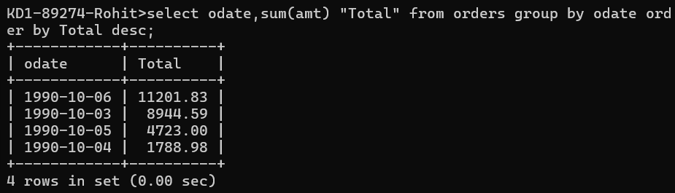  
   QUERY: select odate,sum(amt) "Total" from orders group by odate order by Total desc;