***Assignment – 9* Querying Multiple Tables at Once.**

1. Write a query that lists each order number followed by the name of the customer who made the order.

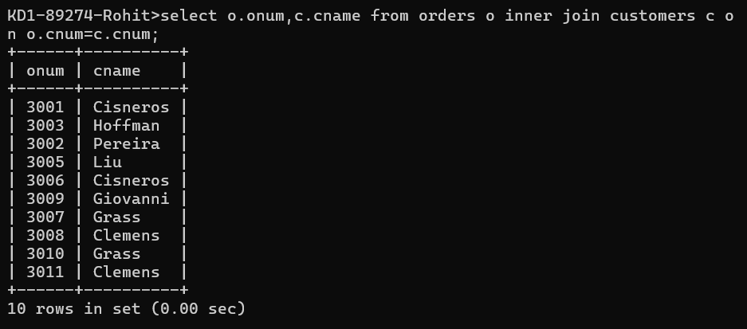

QUERY: select o.onum,c.cname from orders o inner join customers c o

n o.cnum=c.cnum;

1. Write a query that gives the names of both the salesperson and the customer for each order along with the order number.

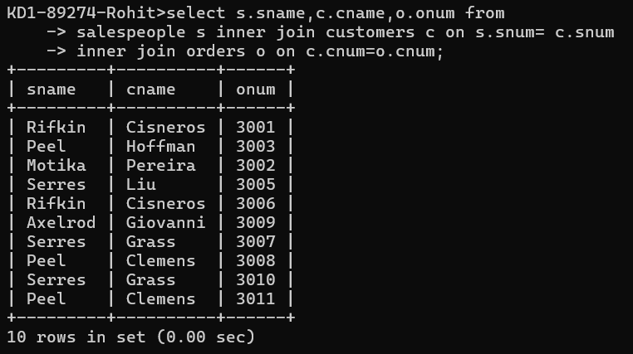

Query: select s.sname,c.cname,o.onum from

salespeople s inner join customers c on s.snum= c.snum

inner join orders o on c.cnum=o.cnum;

1. Write a query that produces all customers serviced by salespeople with a commission above 12%. Output the customer’s name, the salesperson’s name, and the salesperson’s rate of commission.

ANS:

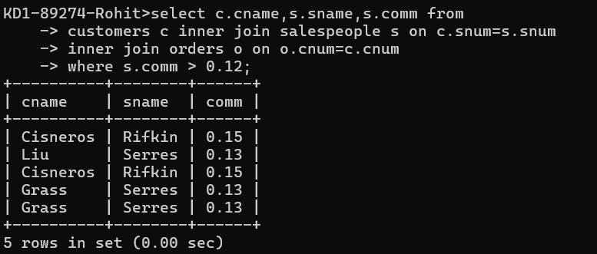

QUERY: select c.cname,s.sname,s.comm from

customers c inner join salespeople s on c.snum=s.snum

inner join orders o on o.cnum=c.cnum

where s.comm > 0.12;

1. Write a query that calculates the amount of the salesperson’s commission on each order by a customer with a rating above 100.   
   