***Assignment – 14***

**Entering, Deleting, and Changing Field Values.**

1. Write a command that puts the following values, in their given order, into the salespeople table: city – San Jose, name – Blanco, comm – NULL, cnum – 1100.

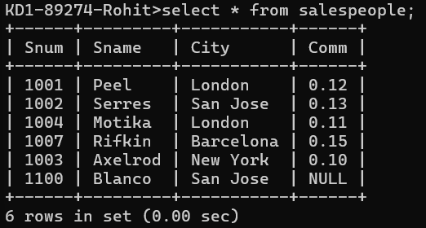  
  
Query: insert into salespeople (city,sname,comm,snum) values('San Jose','Blanco',null,1100);

1. Write a command that removes all orders from customer Clemens from the Orders table.   
   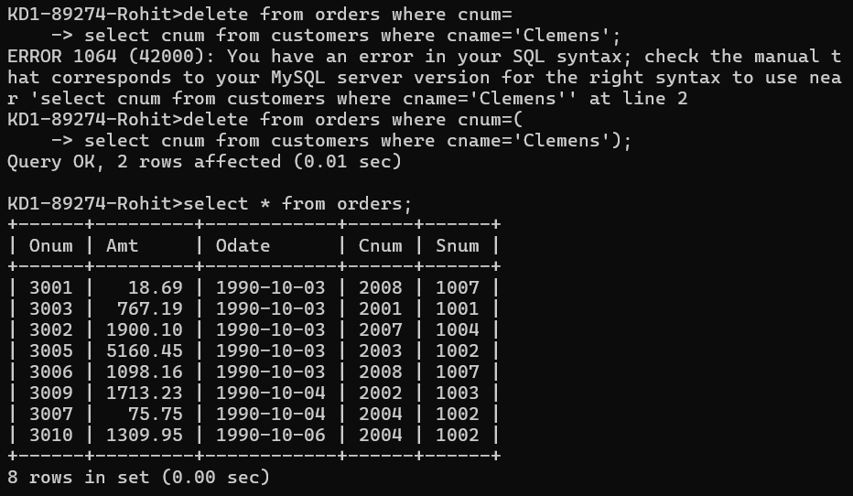  
     
   delete from orders where cnum=(

select cnum from customers where cname='Clemens');

1. Write a command that increases the rating of all customers in Rome by 100.

1. Salesperson Serres has left the company. Assign her customers to Motika.

*Sameer Dehadrai* Page: 1