14_Linux_assignment_XIV
--------------------------------------------------------------------------------------------------------------------------
Create new directory with the name 18oct and create three directories there. (dir1, dir2,
dir3), also create four .txt files (1.txt, 2.txt, 3.txt, 4.txt)
Using find command:
1. List only directories from 18oct.

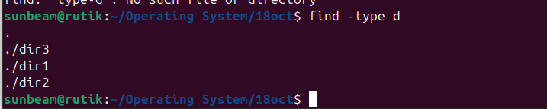
2. List only files.

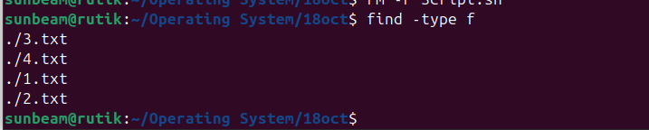
3. Make 2.txt executable, now search the files having permission as rwxr-xr-x (755) from
18oct.
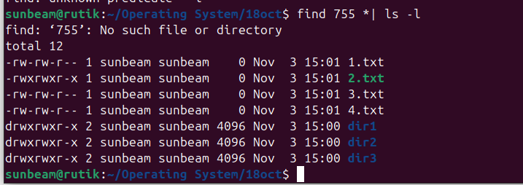

4. Search the file 4.txt.





