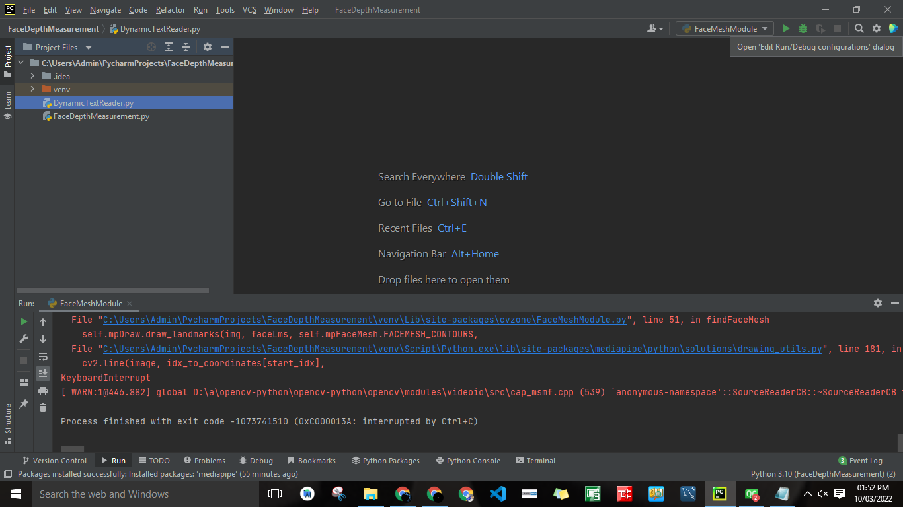

Run both files build it

run autpmatic Created API calles

FaceMeshModule