SCITI: a safe sandbox for supply chain AI
W. P. Carey School of Business, Arizona State University · Department of Supply Chain Management · Kevin Dooley
Every company is being asked what AI will do to its supply chain. Trying it on the real one is expensive and risky. SCITI is a simulated supply chain where AI agents run the firms, so companies, students and researchers can watch what AI decision-makers actually do, at no risk to real operations.
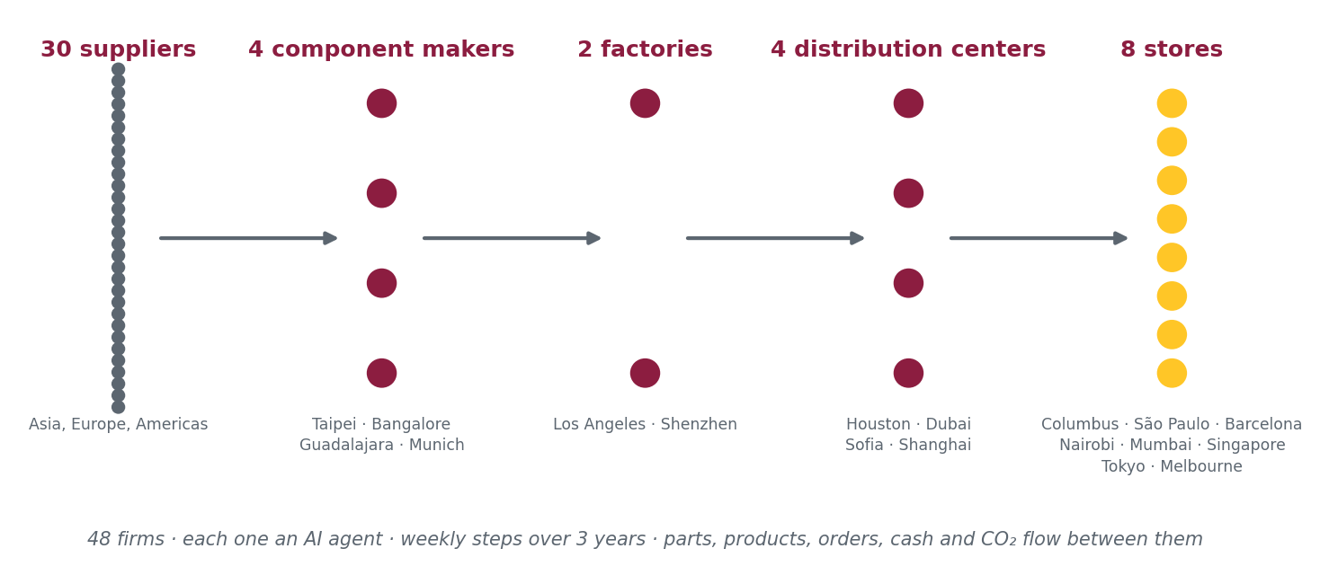
What it is
A 48-firm global supply chain, built from a real case data set, that runs week by week for three simulated years. Each firm is an AI agent with its own budget, persona and goals. Every quarter it can adopt supply chain technologies (machine-learning forecasting, control towers, RFID, planning systems, routing, warehouse robotics, blockchain, risk intelligence), alone or jointly with partners. Projects can fail or fall short, as they do in practice. Disruptions can hit any site. The simulation tracks profit, fill rate, on-time delivery, inventory, bullwhip and CO₂ for every firm and for the whole chain.
What makes it a safe sandbox
- Nothing real is at stake. Firms, data and money are simulated, so a company can test ideas it would never try live.
- Every decision is logged and every run replays exactly. You can see why an agent chose what it chose, and rerun it to check.
- Evidence-based parameters. Technology effects, costs and failure rates come from a logged evidence base of 245 sources, with the weak spots marked.
- Paired comparisons. AI agents, simple decision rules and no-technology baselines run on the same demand and disruptions, so differences are real.
What we have learned so far
AI agents buy protection against disruption that payback rules never buy, and form joint projects when partners will follow. Scattered adopters gain little; connected chains gain most, especially in disruptions. Once realistic implementation risk is included, gains are 40–60% of the “everything works” case, and multi-party technologies suffer most because failures compound across partners.
How a company can work with us
- Bring a question. Which technology first? Alone or with partners? How much buffer? We build the scenario and run it.
- Bring your own structure. The chain, demand and lanes can be reshaped to look like yours, without any of your data leaving your firm.
- Put your people in the loop. Managers or students can play a firm alongside the AI agents, in a replayable, visual run.
Contact: Kevin Dooley, kevin.dooley@asu.edu

