Q1) Creating sample tables and inserting values.

Create the following tables with the given structures and insert sample data as specified:

A) SALESPEOPLE

Snum int (4)

Sname varchar(10)

City varchar (10)

Comm float (3,2)
ANS:
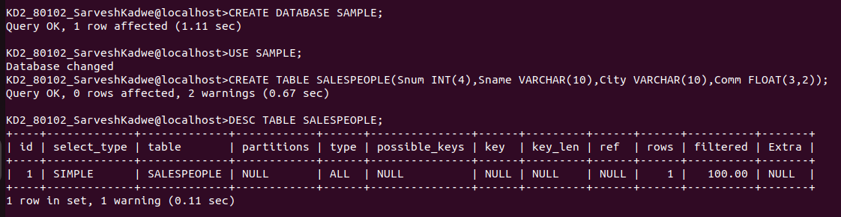

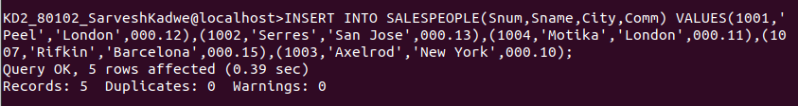
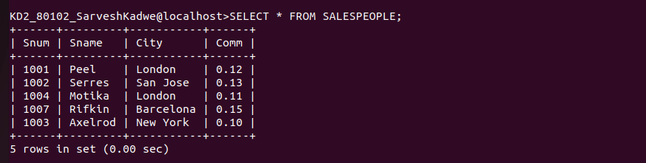

B) CUSTOMERS

Cnum int (4)

Cname varchar (10)
City varchar (10)

Rating int (4)

Snum int (4)

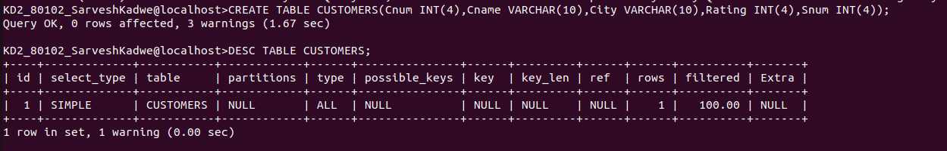
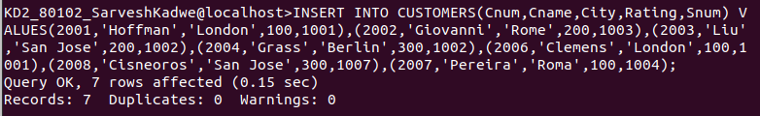

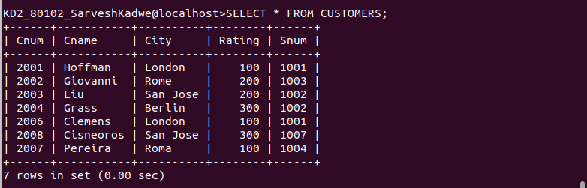

C) ORDERS

num int (4)

Amt float (7,2)

Odate date

Cnum int (4)

